Seraphine Lutecia (Millet) Hargis
July 27, 1880 – December 30, 1948

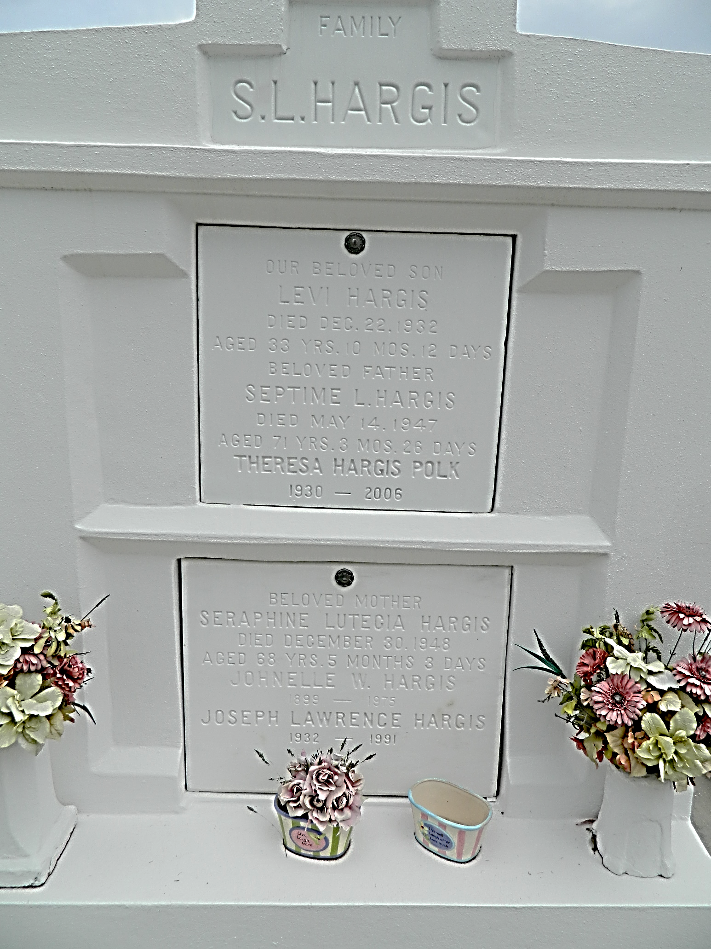

Funeral services were held for Mrs. Seraphine Hargis from her residence in Lions to St. Peter's Catholic Church Saturday with Msgr. J. M. Eyraud performing the rites. Interment was in the church cemetery.

Mrs. Hargis, 68, is survived by a daughter, Mrs. Anthony Monica of Garyville; a son, Thomas Hargis, Lions, and a brother, Anatole Millet of Reserve.
L'Observateur, LaPlace, Louisiana
Saturday, 8 Jan 1949, p. 1

