Catherine Harris

July 27, 1927 – September 2, 2019

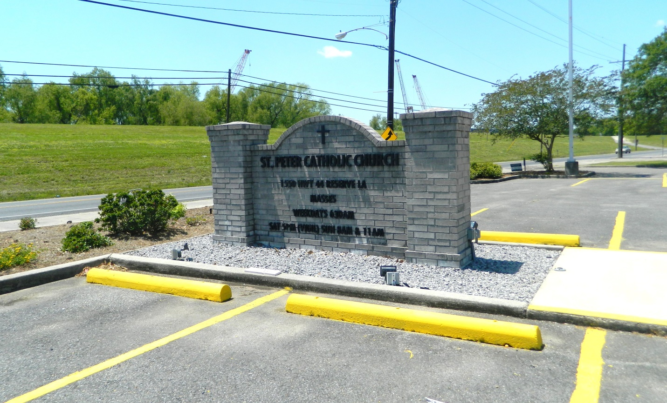

On Monday September 2 while surrounded by her family, God stretched out his arms and welcomed his child home. Catherine was born on July 27, 1927 to the late Louise (Houston) and Joe Brown, Jr. She was the wife of the late Romalice Harris; the mother of: Thelma Meredith Williams, Cordova, TN; Mathews (Loa) Meredith, Houston, TX; Louise Meredith (Poyntell) Johnson, Dallas, TX; Brenda Meredith, Las Vegas, NV; Lolita Scott Moore, Houston, TX; Rodney (Jacqueline) Scott, Gonzales, LA. She will be dearly missed by her 18 grandchildren, 25 great-grandchildren, 4 great-great grandchildren, nieces, nephews and cousins. She was preceded in death by her brother, Charles Brown, Sr. Catherine was a native of Reserve, La. and a resident of Kenner, LA. Funeral services will be held on Saturday, September 7th at 10:00 a.m. at Oakland Baptist Church, 1400 Reverend Richard Wilson Drive, Kenner, LA 70062. Pastor Charles Hurst will be officiating. Catherine will be laid to rest at St. Peter's Catholic Church Cemetery, Reserve, LA. Funeral services will be entrusted to The Baloney Funeral Home.

Published in The Times-Picayune on Sept. 5, 2019