Lillian Harris-Williams
September 27, 1948 – November 5, 2021

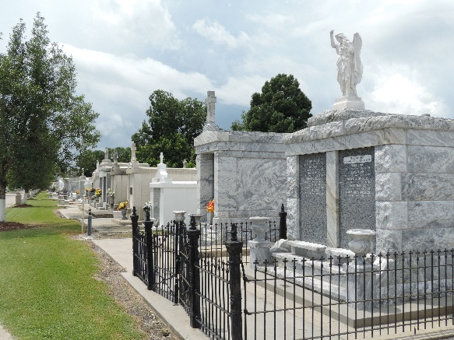
Photo by Team T-Lo

HARRIS-WILLIAMS Lillian Harris-Williams departed this life and entered into eternal rest on Sunday, September 24, 2006 at East Jefferson General Hospital of Metairie, LA.
Beloved wife of George Williams of Reserve, LA by 2nd marriage and the late Henry Harris, Sr. by 1st marriage. Loving mother of Albertha ""Pinky'' Henderson of Reserve, LA, the late Dorothy Thompson, Henry Harris Jr. and Ernest ""Birdie"" Harris. Mother-in-law of Enos Thompson of Homewood, IL, Geraldine Harris of Lutcher, LA and Robert "Toby'' Henderson of Reserve, LA. Grandmother of Terryle Cook of Chicago, IL. Devoted aunt of Verlina Johnson of LaPlace, LA. Also survived by 10 grandchildren, 21 great-grandchildren, 5 great-great-grandchildren, 5 godchildren, a host of nieces, nephews, other relatives and friends.
Relatives and friends of the family; also pastors, officers and members of New Pilgrim Baptist Church, Beechgrove Baptist Church and all neighboring churches; and employees of St. John Parish School Board are invited to attend the Funeral Services on Saturday, September 30, 2006 at 10:30 a.m. at New Pilgrim Baptist Church, 107 Pilgrim Dr., Reserve, LA. Rev. Dr. F. Berring - officiating. Interment in St. Peter Cemetery of Reserve, LA. Visitation will be at the New Pilgrim Baptist Church from 8:00 a.m. until service time. BARDELL'S MORTUARY of Mt. Airy, LA in charge. Information: (985) 535-6837.

The Times-Picayune, New Orleans, Louisiana
Sep. 29, 2006

