Mary Inez (Belanger) Hart
March 14, 1865 – August 31, 1934

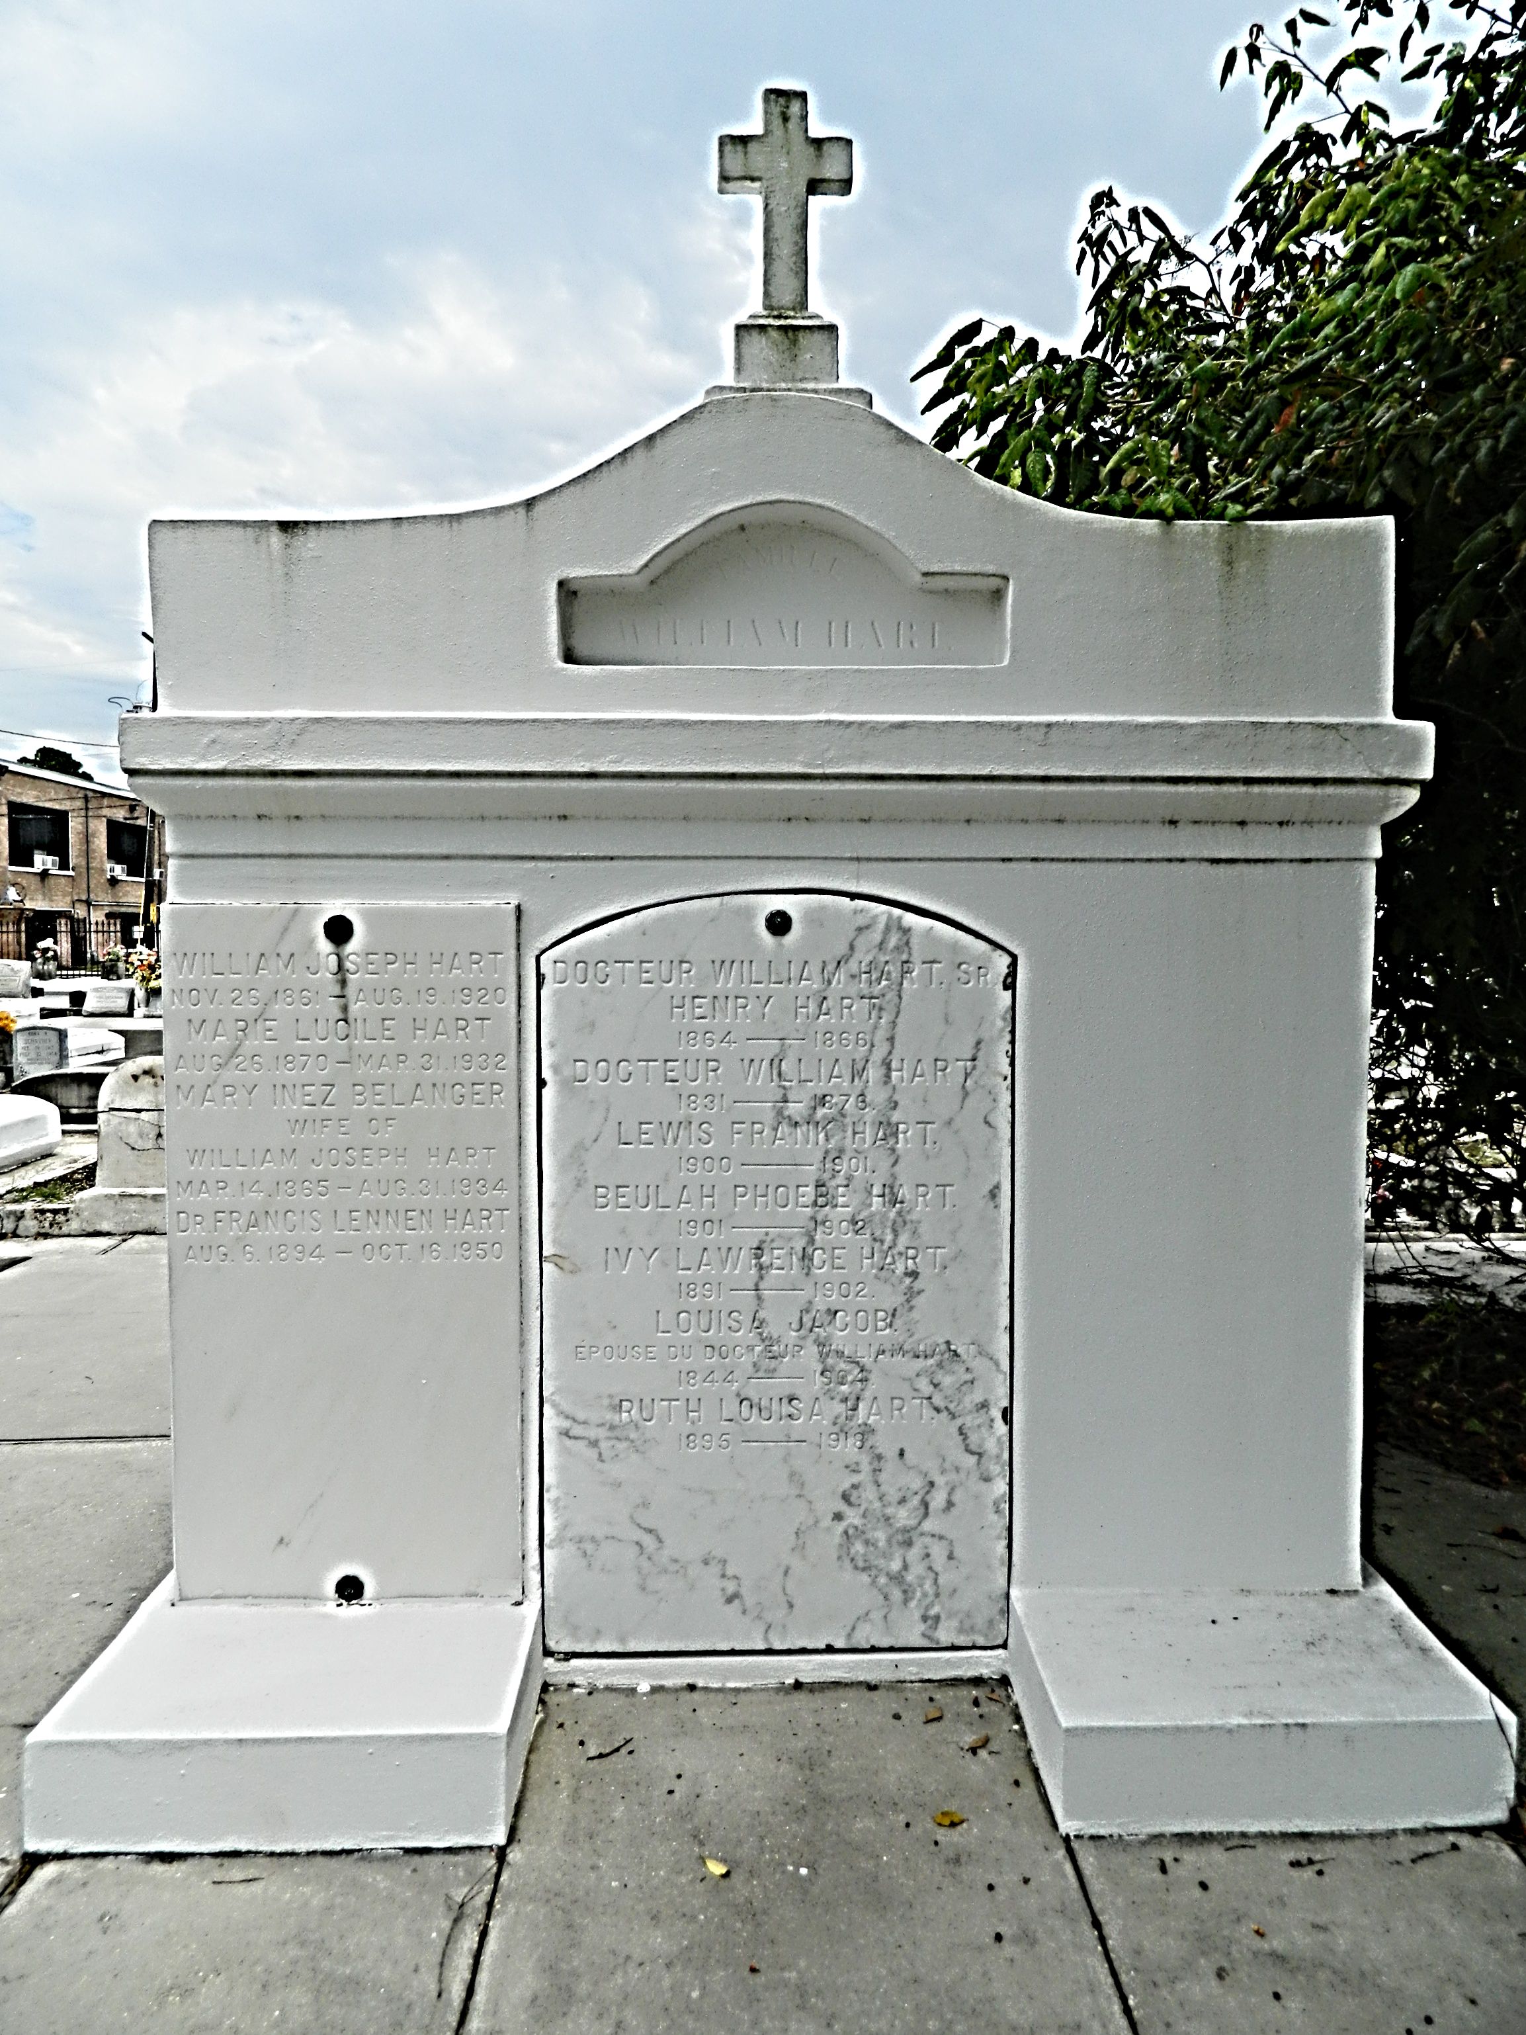

Died at Baton Rouge on 31 Aug 1934 at 3:50 p.m., Mrs. William J Hart (nee Inez Belanger), widow of the late William Hart and mother of W. B. Hart, Jesse A. Hart, Francis L. Hart, Mrs. James W. Malarcher, Mrs. W. B. McHugh, Mrs. Inez Madere and Mrs. Jack Hover, age __ years. Remains forwarded on Saturday, 1 Nov 1934 from Woodruff ____ Home to Reserve, Louisiana. Funeral and interment at St Peter's Cemetery.
The Time-Picayune, New Orleans, Louisiana
1 Sep 1934, p. 2

