Ruth Louisa Hart

1895 – December 14, 1918

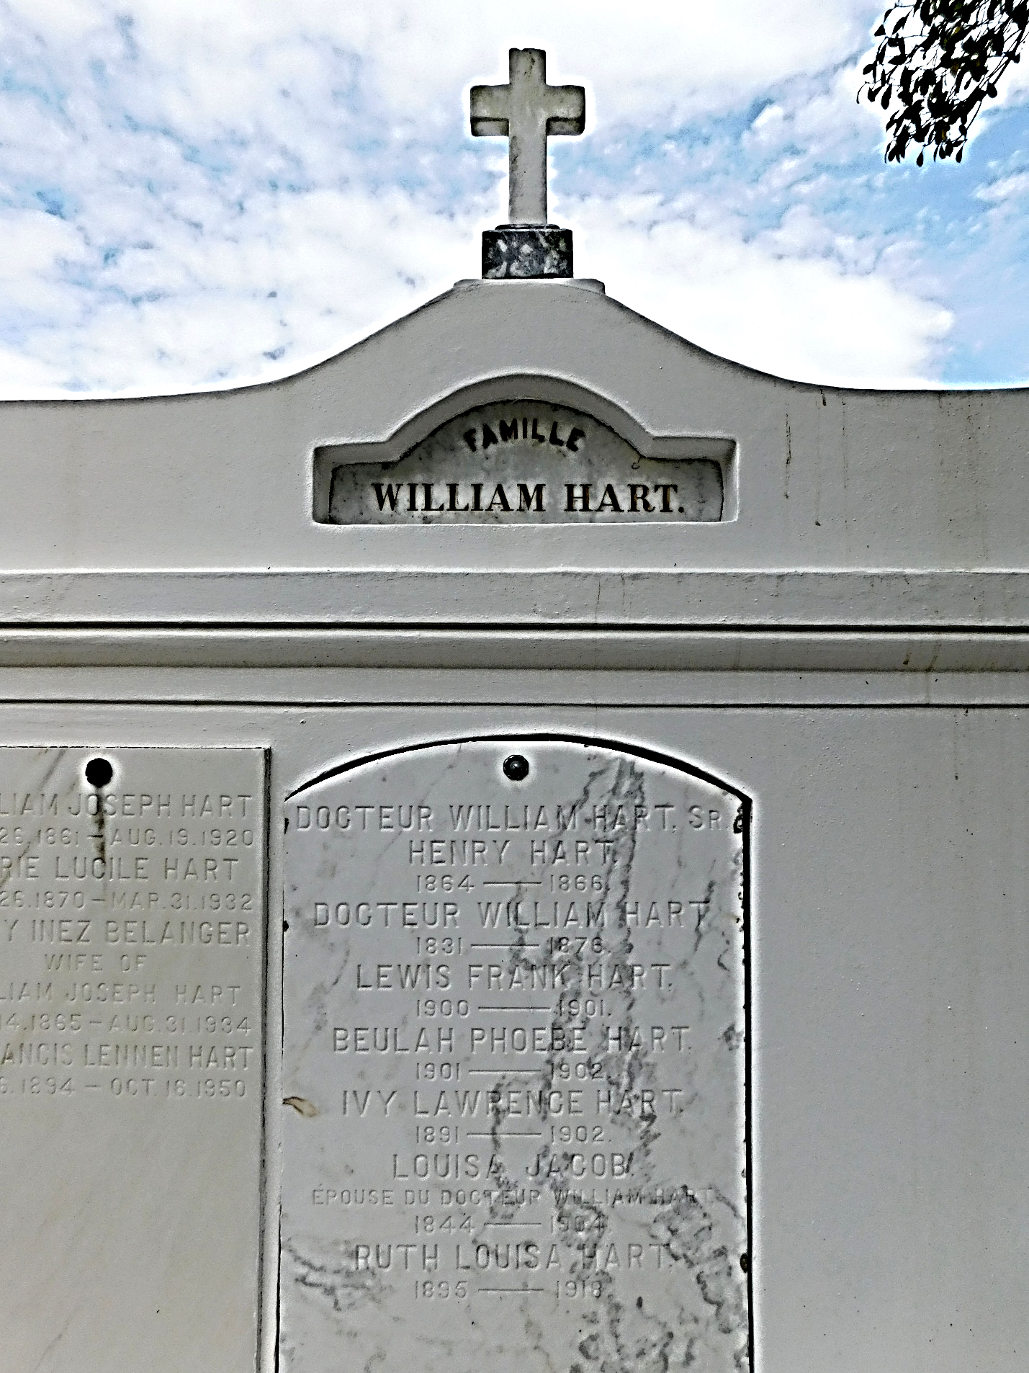

Photo by Mary Agnes Hammett

Miss Ruth Louisa Hart died Saturday, 14 Dec 1918 at her home in Reserve, LA, at age 23 years. She was the daughter of Sheriff William J, Hart of St. John the Baptist Parish.

Her death was caused by Spanish Influenza probably contracted while she attended to influenza patients at the Reserve Emergency Hospital during the recent epidemic.

Funeral services were Sunday, 15 Dec 1918 at St Peter Church with interment in St Peter Cemetery.  
  
Le Meschacebe, LaPlace, Louisiana

21 Dec 1918, p. 5