Judy (Borne) Hartmann
September 8, 1956 – March 6, 2022

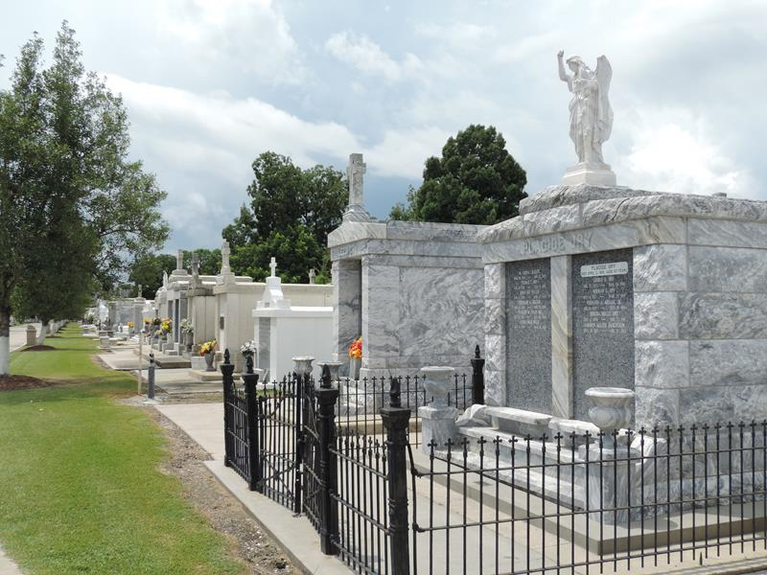

Judy Borne Hartmann, age 65, was called Home on March 6, 2022. She was a native of Reserve, LA, and resident of Baton Rouge, LA.
She was the beloved wife of Don Hartmann Jr for 42 years and loving mother of Heather Hartmann Bagala (Nick). She was survived by grandsons, Anthony Bagala and Micah Bagala; brothers, Stanley Borne; Dennis Borne (Denise); sisters, Paulette Virnich, Amy Ryan (Gene); sister-in-law, Lynne Borne. Also survived by many beloved nieces and nephews.
She was preceded in death by parents, Whitney and Helen Borne; brother, Whitney Borne, Jr.; brother-in-law, Tom Virnich; nephew, Stanley Borne, Jr.
Relatives and friends are invited to attend the visitation on Thursday, March 10, 2022 at St. Joan of Arc Catholic Church, 529 W. 5th St., Laplace, LA from 10:00 am until a Mass of Christian burial at 12:00 pm. Burial follows at St. Peter Catholic Church Cemetery in Reserve, La.

Rose Lynn Funeral Home, Lutcher, Louisiana

