Sylvia (Sterling) Harvey

June 18, 1945 – April 28, 2007

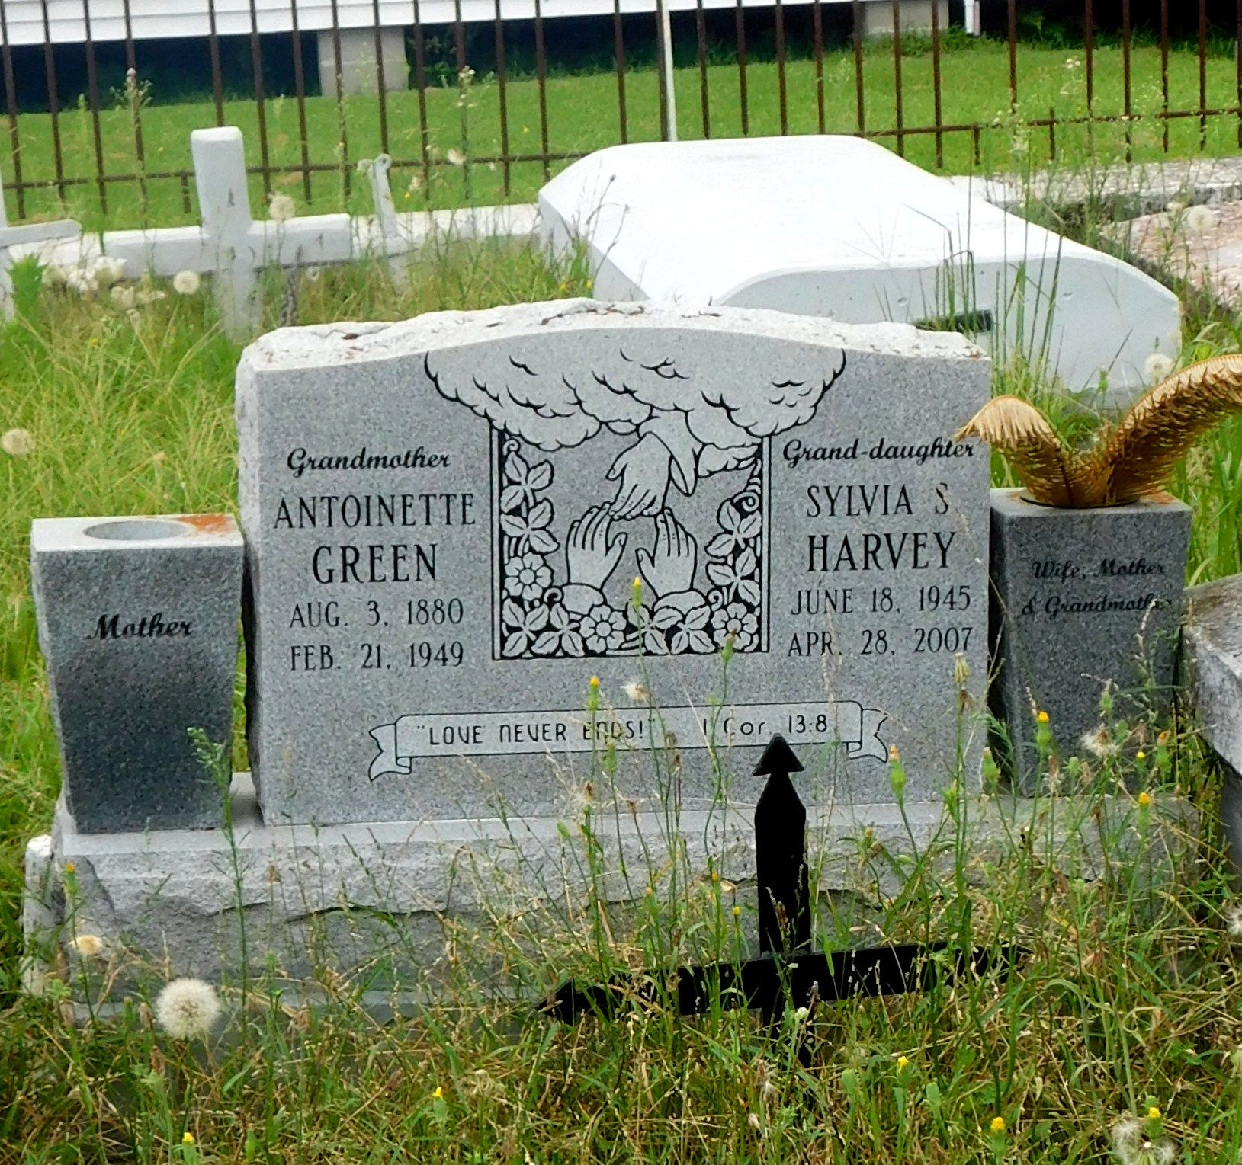

Photo by Mary Agnes Hammett

Sylvia S. Harvey On Saturday, April 28, 2007 At East Jefferson General Hospital, Metairie, La.

Daughter Of Janet Murray Sterling And The Late Edward Sterling, Jr. Wife Of Frank C. Harvey. Mother Of Dr. Antoinette Harvey-Fields, M.D. Step-mother Of Patricia R. Harvey And Frank Harvey, Jr. Mother-In-Law Of Kevin Fields, Sr. Sister Of Claudia S. Davis, Regina S. August, Patricia, Carolyn, Elaine, Milton, Antoine, Gerald And Keith Sterling. Grandmother Of Creshaun Zewalk-Betts, Kevin Fields II, Autumn Fields, Frank Harvey III, Willie Walton Harvey And Joshua Harvey. Also Age 61 Years. A Native And Resident Of Laplace, La.

Times Picayune, New Orleans, Louisiana

May 2, 2007