Alizidie (Scallan) Haydel
September 14, 1930 – January 5, 2016

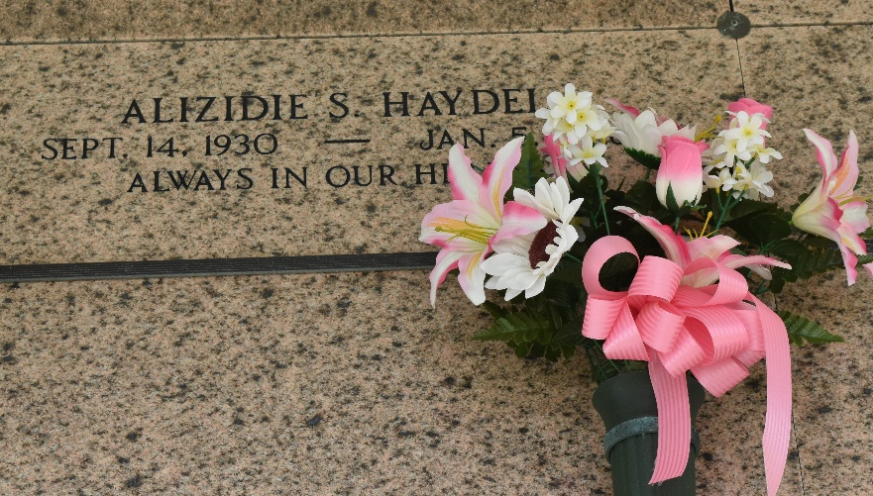

Alizidie "Zadee" Scallan Haydel passed away on Tuesday, January 5, 2016 at the age of 85. She was a native of Plaucheville, LA and a resident of LaPlace, LA for the past 68 years. Zadee was a retired nurse, a parishioner, volunteer and Eucharistic Minister for St. Joan of Arc Church and a recipient of the St. Louis Medallion.
Beloved wife of the late Edgar "June" Haydel, Jr. Loving mother of Kenneth J. Haydel (Cathy), Mary H. Goldman and Jane H. Madere (Danny). Grandmother of Kate Robinson (Shae), Krista Haydel, Adam Goldman, Whitney Arceneaux (Adam), Cory Madere (Melissa), Shawn Madere and Julie Madere. She is also survived by 7 great grandchildren.
She was preceded in death by her parents, Cilton and Stella Couvillion Scallan. Sister of Edmond Scallan (Peggy), Lynn Scallan (Natalie), Carolyn Scallan and the late Marvin Scallan, Kermit Scallan, Delores S. Mayeux, Martha S. Gilbeau and Margaret S. Valois.
The family would like to give a special thanks to the staff of Ormond and Twin Oaks Nursing Homes.
Relatives and friends of the family are invited to attend the Funeral Mass at St. Joan of Arc Catholic Church, 529 W. 5th St., LaPlace on Thursday, January 7, 2016 at 12:00 p.m. Visitation will begin in the church at 10:00 a.m. Interment in St. Peter Cemetery. In lieu of flowers, masses or donations to the Alzheimer's Association Louisiana, 3445 N. Causeway Blvd., Ste. 902, Metairie, LA 70002, preferred. Arrangements by Millet-Guidry Funeral Home.

The Times-Picayune, New Orleans, Louisiana
Jan. 5 to Jan. 6, 2016

