Alma M. (Cambre) Haydel
July 20, 1900 – November 12, 1979

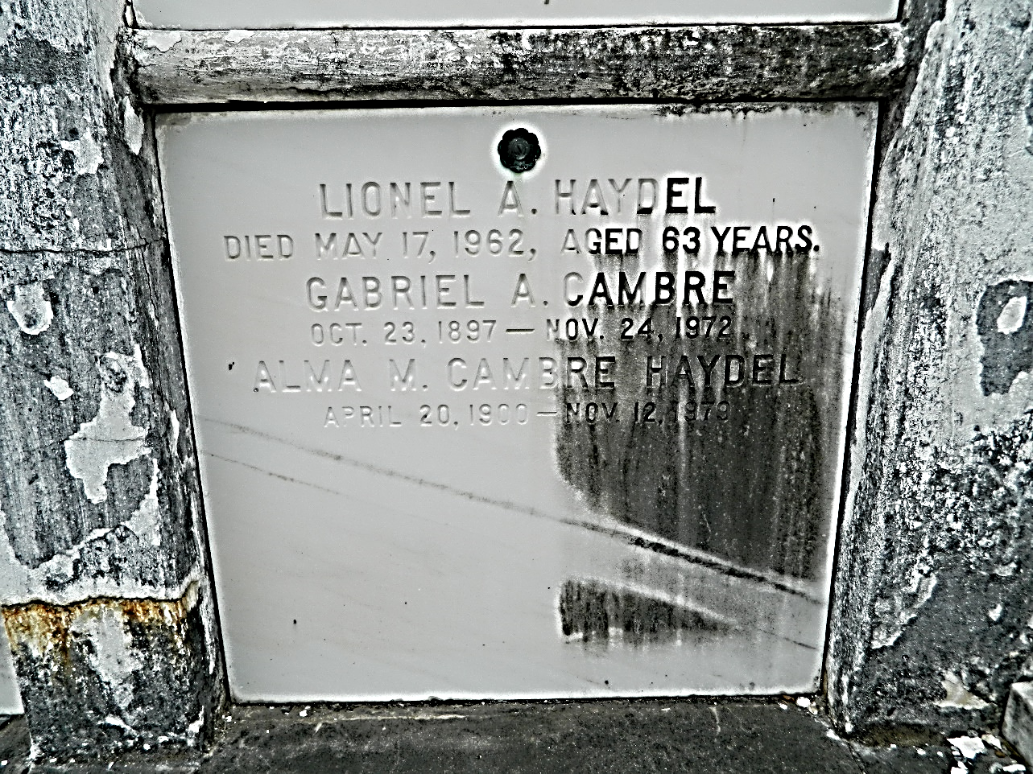

Alma Cambre Haydel, a native of Laplace, Louisiana, and a resident of New Orleans, died Monday 12 Nov 1979 at 2:30 a.m. at age 79 years.

She was the wife of the late Lionel A Haydel and the sister of Maxime and Whitney Cambre of River Ridge, Louisiana, and Walter Cambre of Metairie, Louisiana, and the late Louis A., Denise and Gabriel Cambre.

Services were Tuesday 13 Nov 1979 at St Joan of Arc Catholic Church, Laplace, with interment in St Peter Cemetery, Reserve, Louisiana.
The Times-Picayune, New Orleans, Louisiana
13 Nov 1979

