Dane Michael Haydel
July 29, 1966 – November 18, 2014

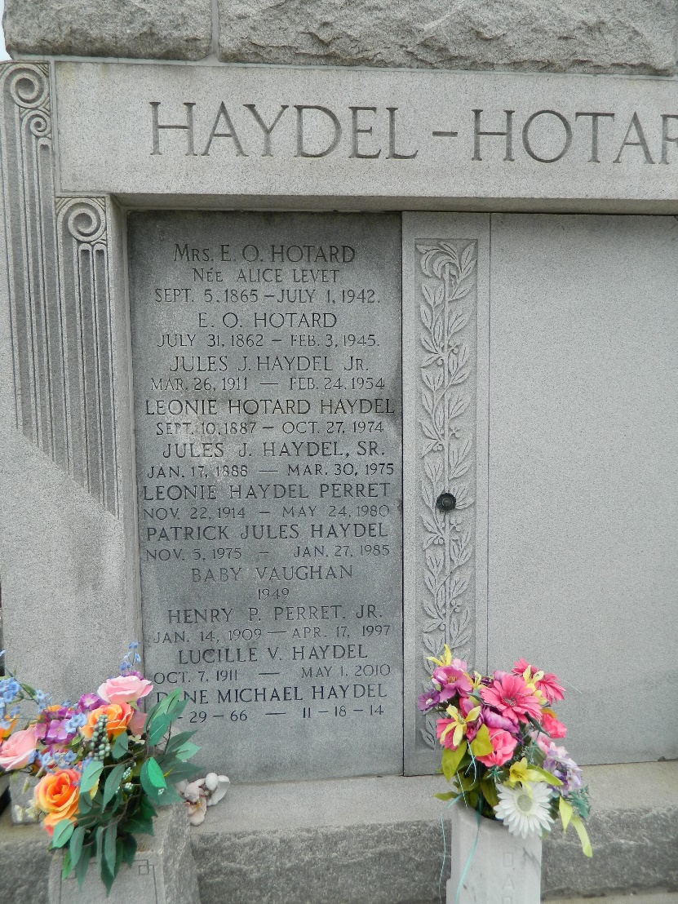
Dane Haydel, 48, passed away on Tuesday, Nov. 18. He was a native of New Orleans and a resident of LaPlace. Haydel was a former husband of Lisa Haydel; father of Adam and Jessica Haydel; son of Sandra Akin Hotard and Valery 'Val' Haydel; brother of Mathew Haydel and the late Patrick Haydel; uncle of Kayla Haydel; step-son of Debra Haydel; and brother-in-law of Keri Haydel. Relatives and friends are invited to attend the Funeral Mass at St. Joan of Arc Catholic Church, 529 W. 5th St., LaPlace on Saturday, Nov. 22, at 11 a.m. Visitation will begin in church at 9 a.m. Interment follows in St. Peter Cemetery. Arrangements by Millet-Guidry Funeral Home. To view or sign the online guest book, visit milletguidry.com.
L'Observateur (LaPlace, Louisiana
Wednesday, November 19, 2014
Contributed by Jane Edson

