Earl J. Haydel
July 18, 1924 - July 11, 1944

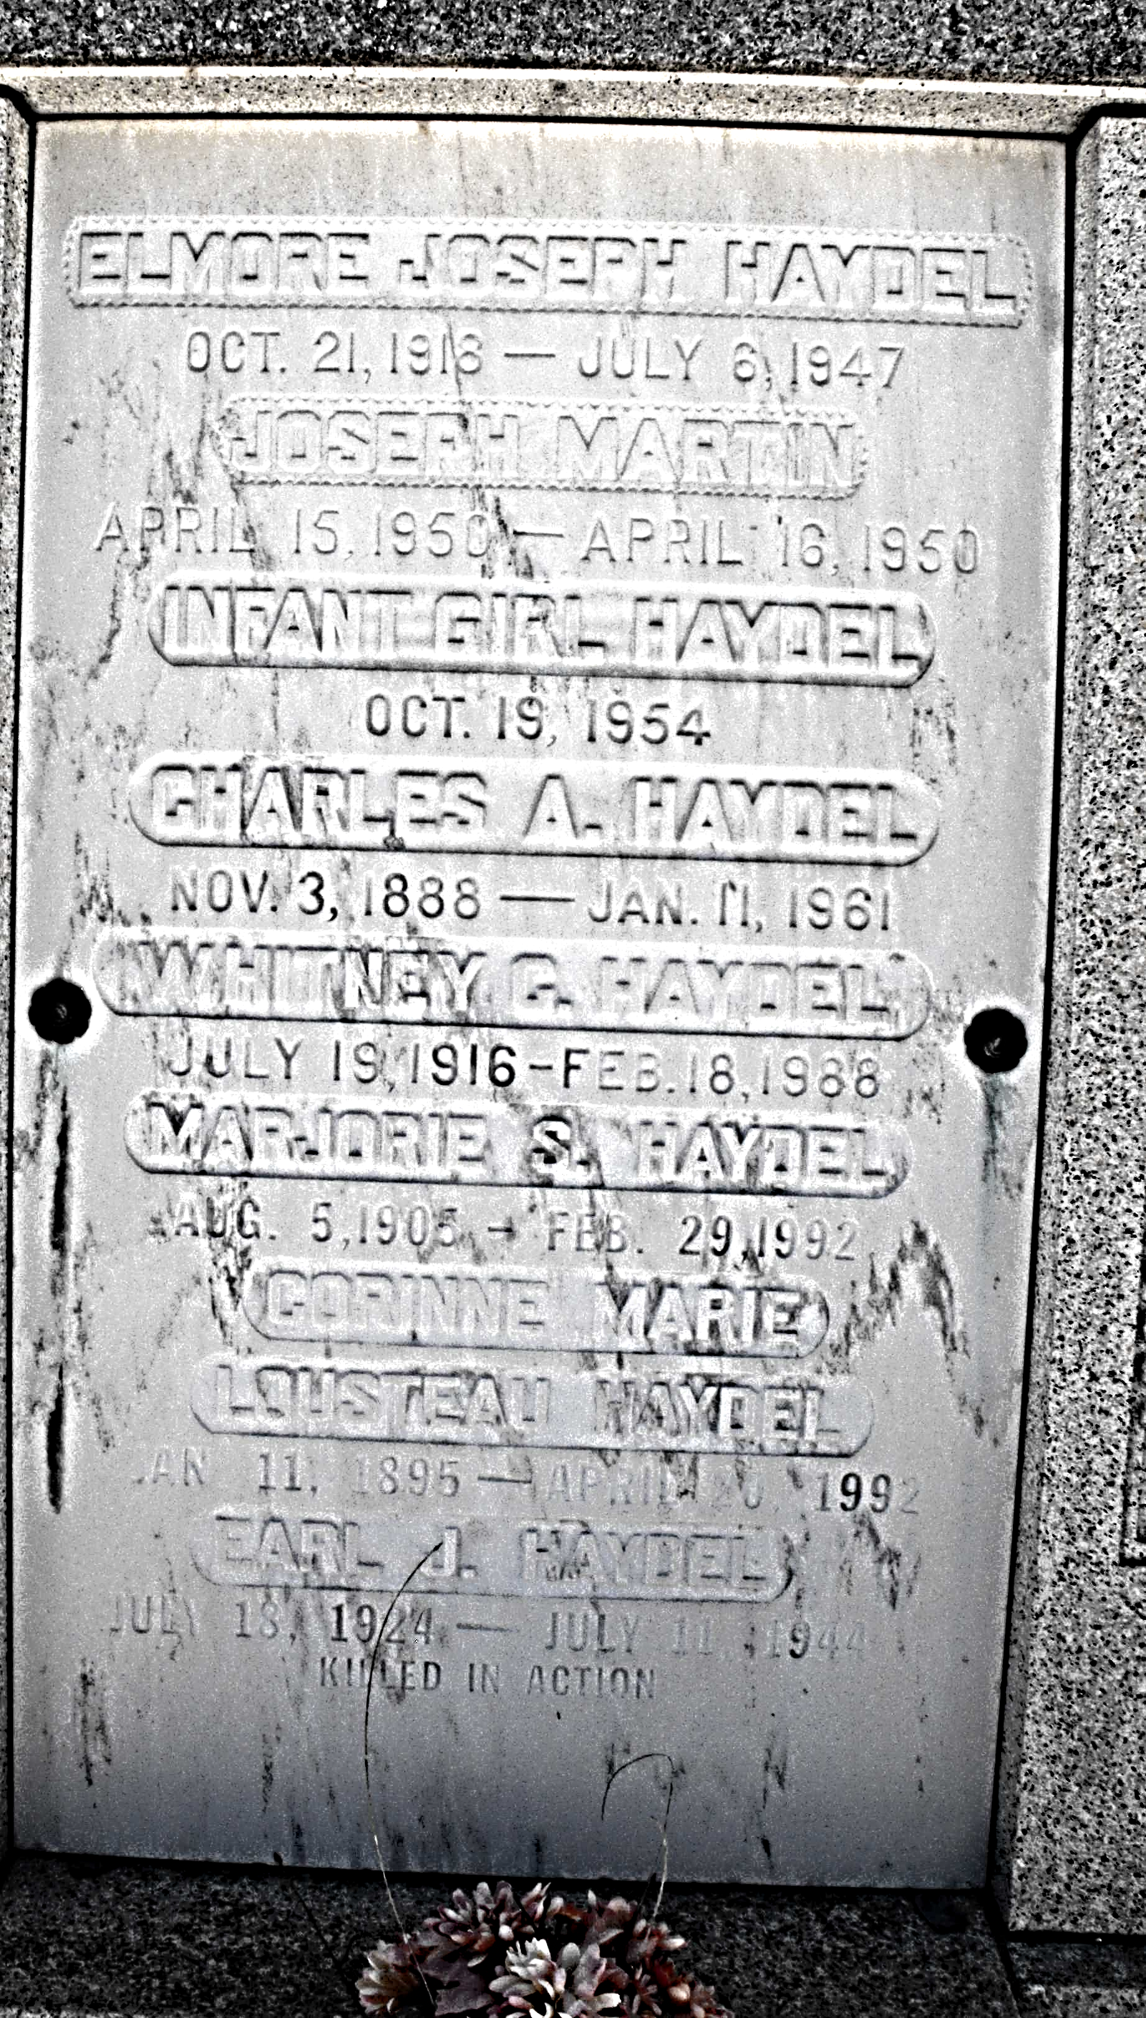

U.S., Headstone and Interment Records for U.S., Military Cemeteries on Foreign Soil, 1942-1949
Name Earl J Haydel
Rank Corporal
Residence Place Louisiana
Type of Medal Air Medal, Purple Heart
Service Number 38497056
Military Unit 704th Bomber Squadron, 446th Bomber Group, Heavy
Military Branch U.S. Army Air Forces
War World War II
Death Date 11 Jul 1944
Cemetery Section Tablets of the Missing
Cemetery Cambridge American Cemetery
Burial Place Cambridge, England
**

Earl J Haydel from tree Haydel Family Tree

Birth 18 Jul 1924 Louisiana, USA
Residence 1940 St Tammany, Louisiana, USA
Death 11 Jul 1944 Cambridge, Cambridgeshire, England
Father Charles Alphonse Haydel (1888-1961)
Mother Corrine Lousteau (1895-1992)
51468 People 6 Records 6 Sources

