Edgar Joseph Haydel Jr.

October 10, 1924 – June 9, 2004

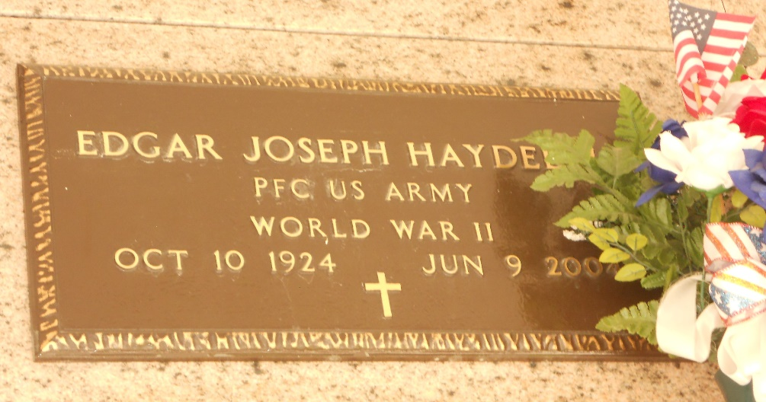

Photo by Mary Agnes Hammett

Edgar "June" Haydel Jr died Wednesday 9 Jun 2004 at 5:30 pm at age 79 years. He was a native and resident of Laplace, Louisiana.

He was the husband of Zadee Scallan Haydel and the father and father-in-law of Kenneth and Cathy Haydel, Mary Goldman and Jane and Danny Madere. He was the son of the late Edgar Sr and Lucette Haydel and the brother of Lucette Hidalgo, Doris Vicknair and the late Aline Holmes, Alma St Pierre and Rita Gautreaux. He was a veteran of WWII.

Services were Friday 11 Jun 2004 at St Joan of Arc Church, Laplace, with interment in St Peter Cemetery, Reserve, Louisiana.

The Times-Picayune, New Orleans, Louisiana

11 Jun 2004