Marguerite (Schexnayder) Haydel-Gautreaux
March 26, 1916 – October 21, 2003

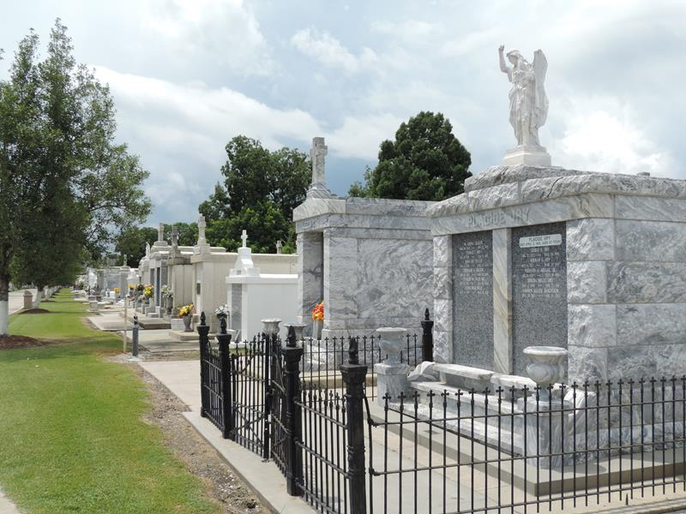

Marguerite S. Haydel Gautreaux, on Tuesday, October 21, 2003 at 5:33 P.M.
Beloved wife of the late Lawrence Haydel and by second marriage of Eddie Gautreaux. Mother of Kathy Hauk, Trent Haydel, and the late Billy Haydel. Daughter of the late Flagile and Anita Schexnayder. Sister of Alma LeBlanc, Thelma Boe, Nolan Schexnayder and the late Walter, Flagile ''Butch'', Claude, Norbert, Herman and Larry Schexnayder, Dorothy Chauvin and Mable Stein. Also survived by 3 grandchildren and 3 great grandchildren. Age 87. A native of Vacherie and a resident of Reserve for the past 70 years.
Relatives and friends of the family are invited to attend services. Visitation at MILLET-GUIDRY FUNERAL HOME, 2806 W. Airline Hwy., LaPlace on Thursday, October 23, 2003 from 11:00 A.M. until 2:00 P.M. Folllowed by religious services in the funeral home chapel at 2:00 P.M. Burial in St. Peter Cemetery in Reserve.
Times Picayune, New Orleans, Louisiana
October 23, 2003

