George Louis Haydel
April 13, 1881 – February 20, 1938

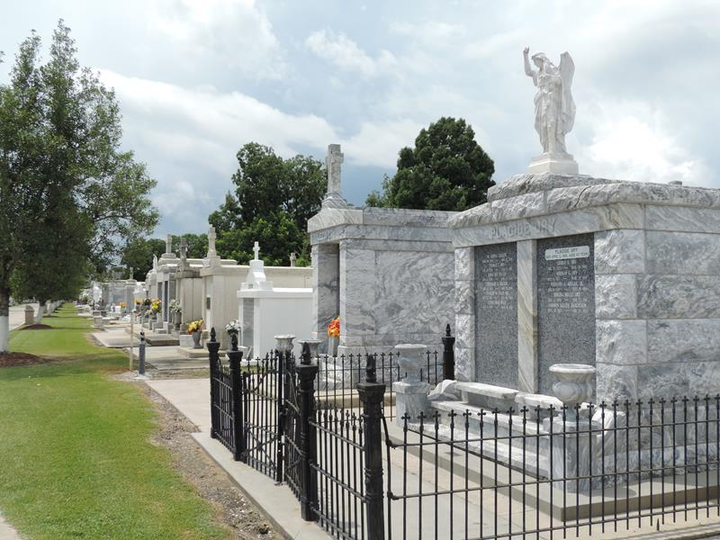

George Haydel, beloved husband of Lillian Englade and father of Mrs. C. E. Harding of New Jersey, Mrs. F. Fabre of Reserve, Mrs. W. Hahn, Mrs. E. LeBlanc and Verna, Ruth, Mary Margaret, Myrtis, Erwin and Clifford Haydel of Lions, La., also survived by six grandchildren, aged 56 years 10 months 8 days. Jules Millet funeral home in charge of services at St. Peter's Church. Interment in St. Peter's cemetery, Reserve, La.
Times-Picayune, New Orleans, Louisiana
21 Feb 1938, p. 2
**

Haydel, George L., who resides at Lions, in St. John the Baptist parish, of which vicinity he is a native, was born April 13, 1881, and is a son of Valcour and Juliane (Bodin) Haydel, both of whom were born in the same region as was the son. The paternal grandfather, Pierre Haydel, was a native of Canada, from which country he came to Louisiana and located in St. John parish at an early date. He followed the business of a planter. The maternal grandfather, Julian Bodin, was born in France, and located in St. John parish immediately after coming to this country, devoting his energies to the vocation of a planter.
Nine children were born to Valcour Haydel and wife, as follow: Clement, who married Amelie Sare, is living in St. James parish (his wife had been married twice previously and has 3 children by former unions); Aledor, who married Josephine Ancar, is living at Garyville; Ferdinand, who married Louise Keller, is farming in Iberville parish; Dexson, who married Madeline Kremmer, is farming in Ascension parish; Julian, who married Marie Ancar, is living at Garyville; Pierre, died in infancy; George L., the subject of this sketch. The 8th child died at the age of 18 months and the 9th at a still earlier age.
George L. Haydel received his earlier education at public schools in the vicinity of his birthplace. Later he attended private schools in the same locality. At the age of 15 years his schooling was terminated and he went to work as a farm laborer, and so continued about 5 years, then he became manager of a plantation. After passing 4 years in the latter capacity he rented some land and began growing cane on his own account. He now cultivates Idaho plantation, embracing 600 acres, upon which he grows sugar cane and corn as principal crops, and is doing a thriving business.
Mr. Haydel has affiliated with the democratic party from the time of casting his first ballot. He is a member of the Catholic church, Knights of Honor, and Woodmen of the World, Jan. 18, 1905, George L. Haydel was married to Lillian Englade, daughter of Ulysses and Zoa (Perllioux) Englade, of St. James parish, where the former follows the vocation of a planter. His wife is now deceased. Five children have been born to Mr. and Mrs. Haydel, namely: Clifford, Lima, Edna, Pearl, and Erwin, all of whom are living.
Louisiana: Comprising Sketches of Parishes, Towns, Events, Institutions, and Persons, Arranged in Cyclopedic Form (volume 3), pp. 683-684. Edited by Alcée Fortier, Lit.D. Published in 1914, by Century Historical Assoc.

