James Augustin Haydel

May 3, 1885 – April 24, 1963

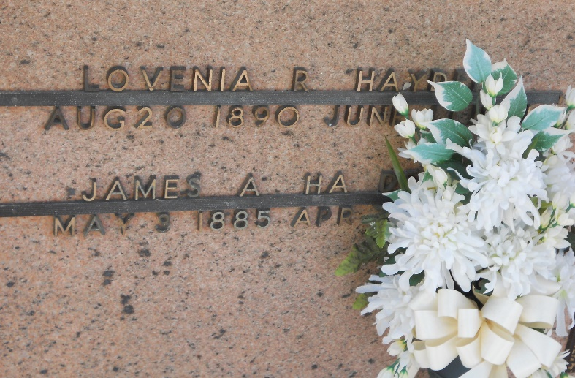

Photo by Team T-Lo

HAYDEL – At his residence, Laplace, La., on Wednesday, April 24, 1963, at 12:15 o’clock a.m. James A. Haydel Sr., husband of the late Lovenia Roubleau; father of Mrs. Valley Thibodeaux, Mrs. Lester Louque and Mrs. Ivan Dupre all of Laplace, La., Mrs. Clancy Matherne of Norco, La., James A. Haydel Jr. of Ponchatoula, La.; also survived by 13 grandchildren and one great-grandchild; aged 78 years; a native and a resident of Laplace, La.

Relatives and friends of the family are invited to attend the funeral. Services from Millet Funeral Home, Laplace, La., on Thursday, April 25, 1963 at 10 o’clock a.m. Religious services at St. Joan of Arc Church, Laplace, La. Interment in St. Peter’s Mausoleum, Reserve, La.

The Times-Picayune, New Orleans, Louisiana

Thursday, April 25, 1963, p. 10, col. 6