Leonie (Hotard) Haydel

September 10, 1887 – October 27, 1974

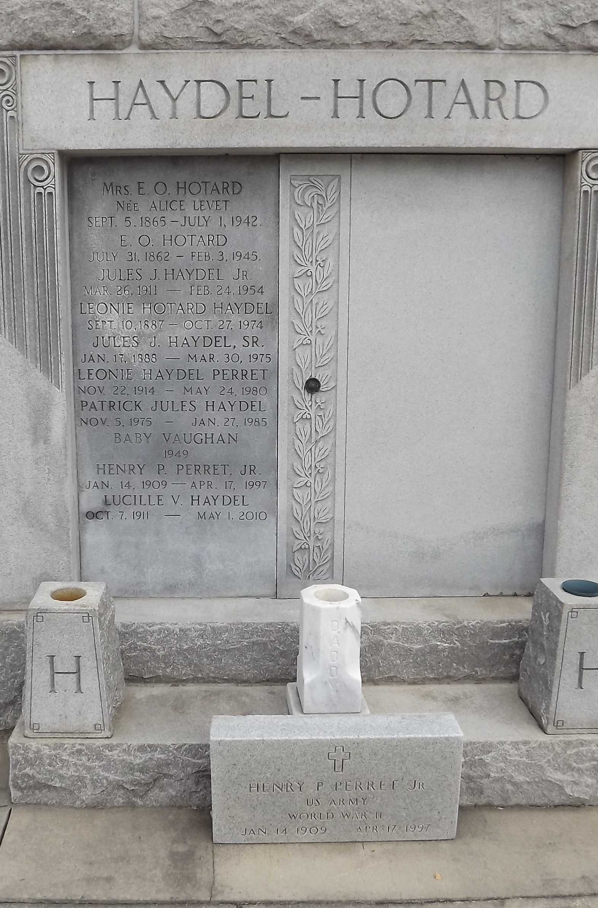

Photo by Mary Agnes Hammett

Wife of Jules J. Haydel Sr. Daughter of the late Ozeme Hotard and Alice Level. Mother of Mrs. John (Alice) J. Millet, Mrs. Sydonie Level, both of New Orleans, Mrs. Henry (Leonie) Perret of Reserve, LA and the late Jules J. Haydel Jr. Sister of Emile Hotard of Reserve, La., O. S. Hotard of Thibodeaux, La., and the late Etienne Hotard of Reserve, La. Aged 87 years. A native of St. Charles Parish and resident of Reserve, LA.

The Times-Picayune, New Orleans, Louisiana

October 30, 1974, p. 16