Lucette (Madere) Haydel

January 10, 1891 – September 10, 1940

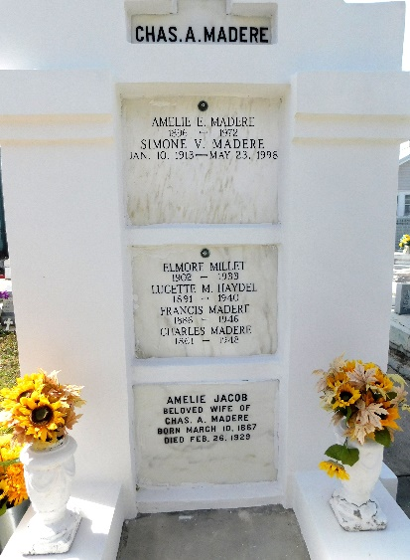 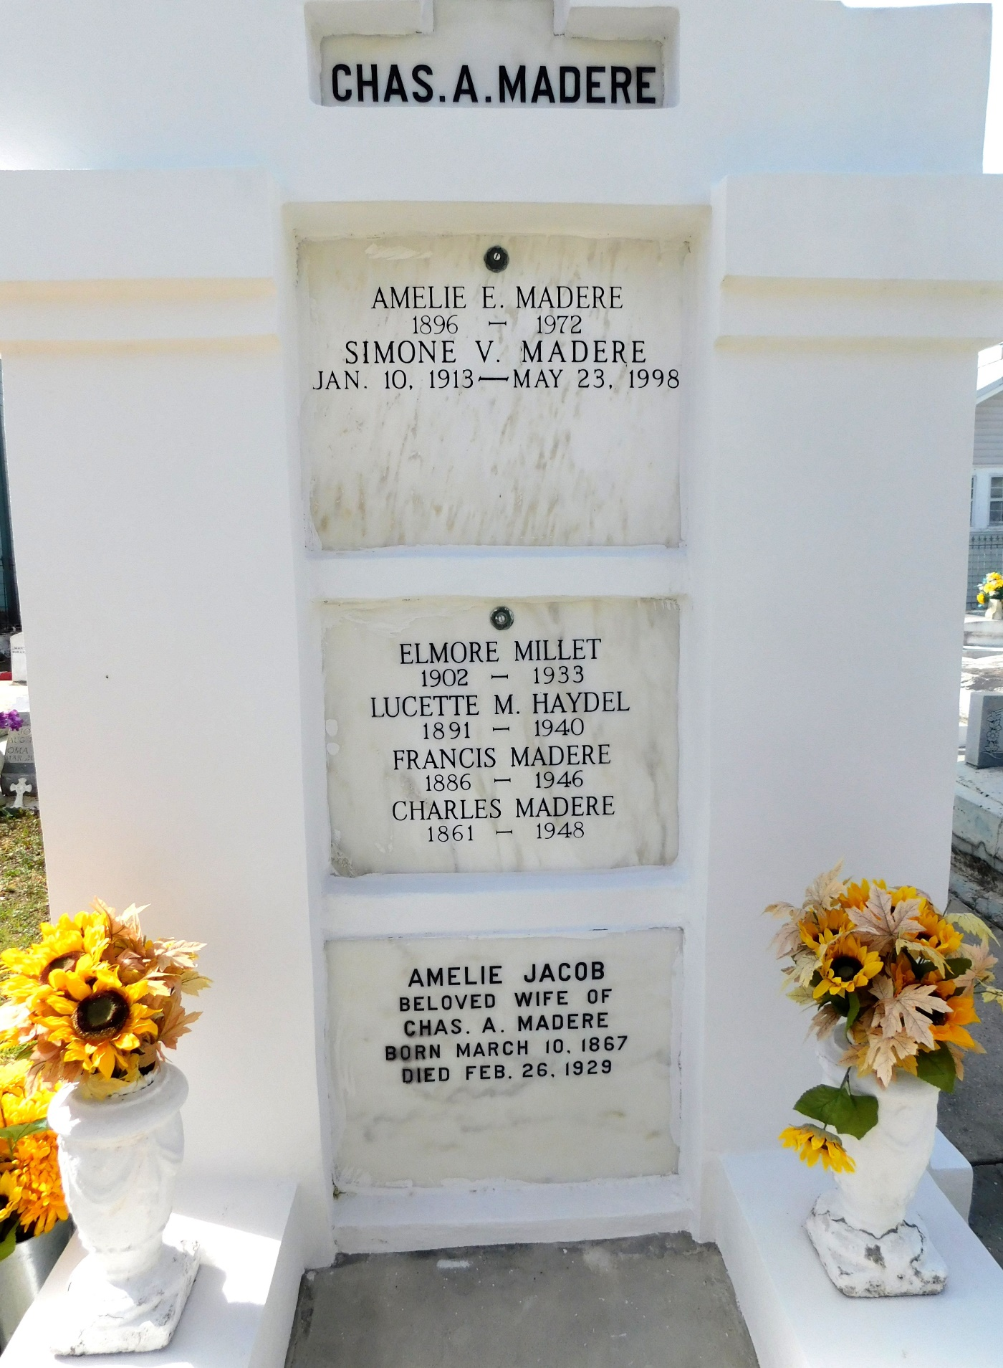

Photo by Mary Agnes Hammett

Lucette Madere Haydel, of Laplace, Louisiana, died on Tuesday, 10 Sep 1940 at 2:30 o'clock a.m. She was the wife of Edgar Haydel and mother of Mrs. Clyde Holmes and Mrs. Joseph Sutton, Alma, Lucette, Edgar Jr and Doris Haydel. Aged 49 years and 8 months.

Relatives and friends of the family are invited to attend the funeral which will take place for the Jules Millet Funeral Home, Reserve, Louisiana, on Wednesday 11 Sep 1940 followed by religious services at St Peter's Catholic Church, Reserve. Interment in St Peter Cemetery.

The Times-Picayune, New Orleans, Louisiana

11 Sep 1940, p. 2