Lucille Marie (Vicknair) Haydel

October 7, 1911 – May 1, 2010

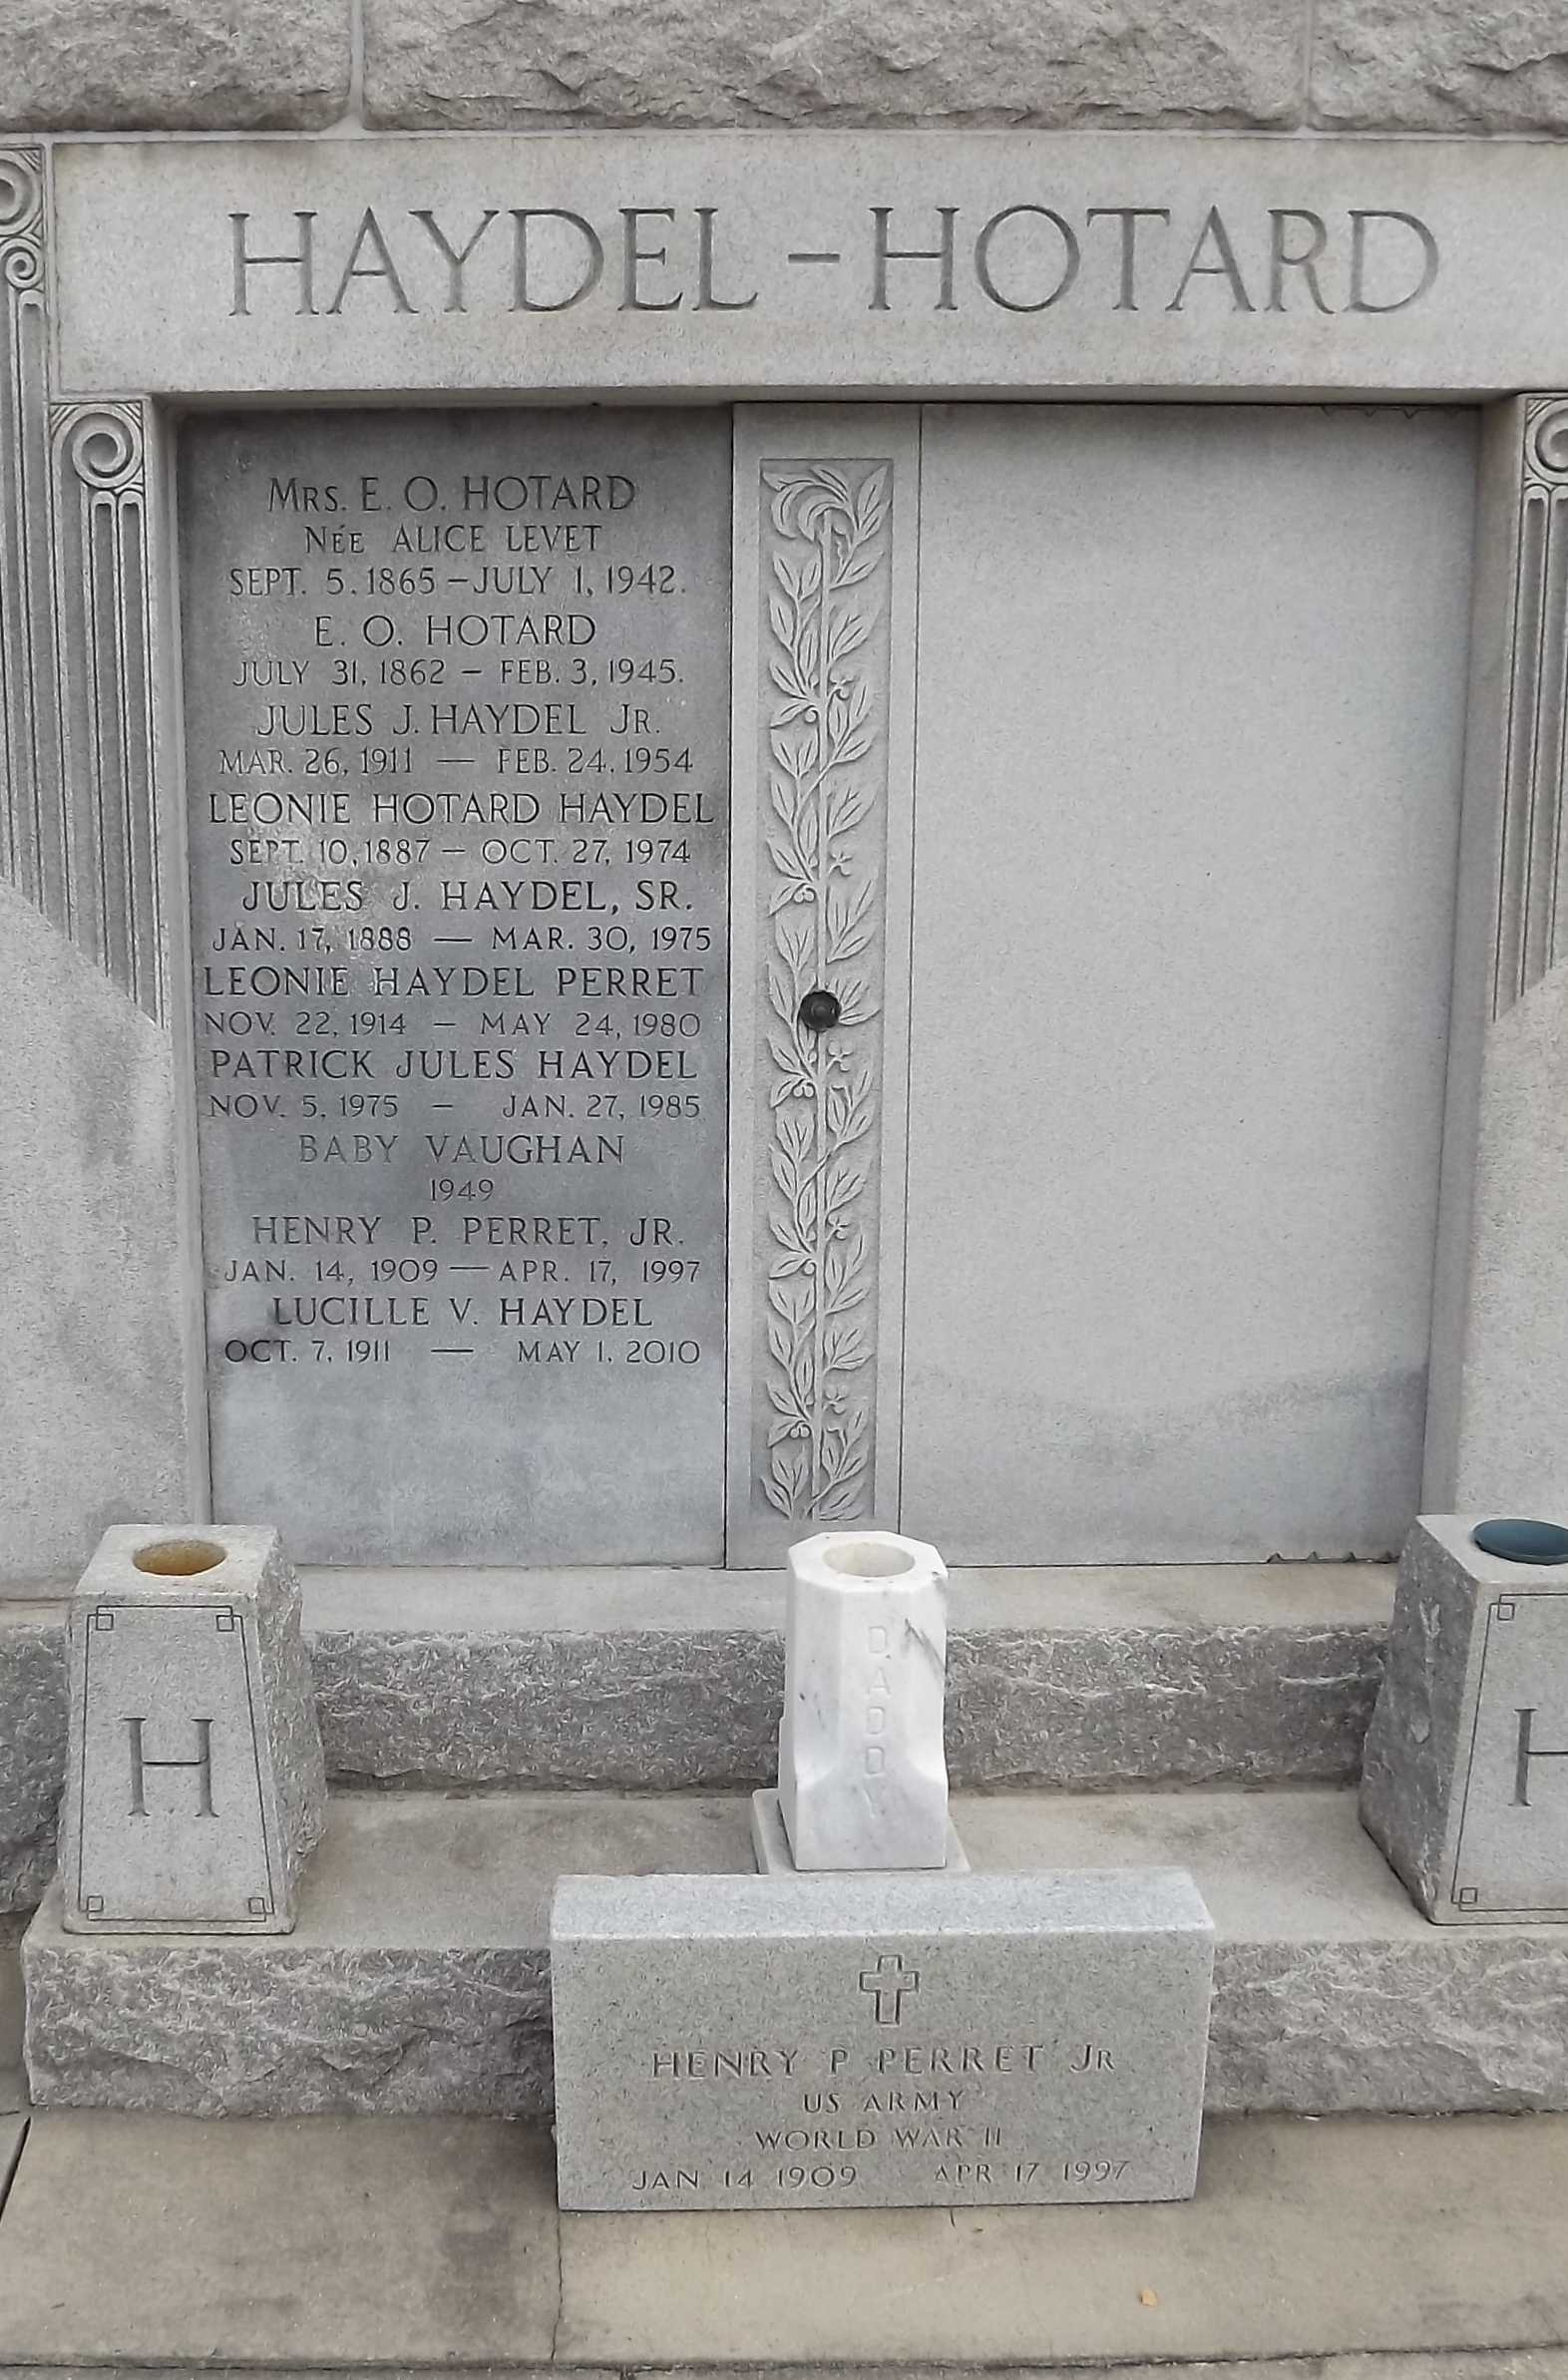

Photo by Mary Agnes Hammett

Lucille Vicknair Haydel passed away on Saturday, May 1, 2010.

Beloved wife of the late Jules Haydel. Mother of Harold (Bubby) and wife Janice, Bert and wife Shirley, Ralph and wife Donna, Valery and wife Debbie Haydel, Gloria Vaughn and husband Conrad and Janice French and friend Walter. Also survived by 17 grandchildren and 1 deceased, 26 great-grandchildren and 3 great-great-grandchildren. Daughter of the late Wilfred and Aline Vicknair. Sister of the late Percy and Wilfred Vicknair, Bernice Roth, Minnie Matte, Hazel Delatte, Rose Lowry, Natalie Ramirez, Mae Montz and Edna Becnel.

Special thanks to Maison Oaks and River Region Hospice. A very special thanks to her dear friend Glassy. Age 98. A native of Garyville, LA and a resident of New Orleans and LaPlace.

Relatives and friends are invited to attend services. Visitation at St. Joan of Arc Catholic Church, 529 West 5th Street, Laplace, on Tuesday, May 4, 2010 from 9:00 AM until 11:00 AM. Followed by a Mass at 11:00 AM. Burial in St. Peter Cemetery, Reserve. Arrangements by Millet-Guidry Funeral Home.

The Times-Picayune, New Orleans, Louisiana

May 3, 2010