Melvin Louis Haydel
March 3, 1933 – December 16, 2023

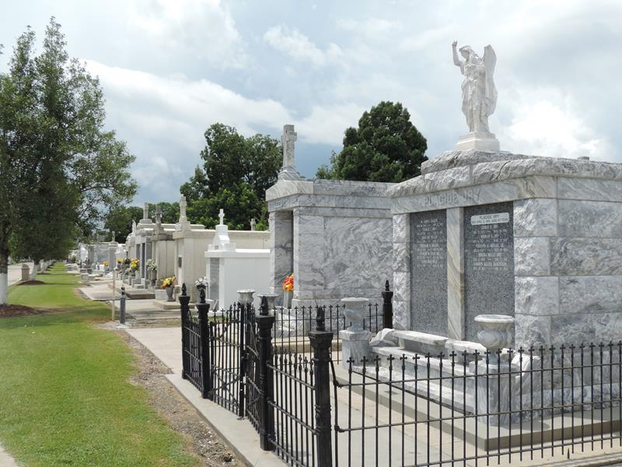
Photo by Mary Agnes Hammett

Melvin Haydel a lifelong resident of Reserve, LA passed away on Saturday, December 16, 2023 at the age of 90.
Beloved husband of Patricia “Pat” Haydel for 66 years. Son of the late Abner Haydel and Amy Brou Haydel. Brother of Abner Haydel, Jr. (the late Rita), Earl Haydel (the late Dot), and the late Lloyd Haydel. Also survived by nieces, nephews, and friends.
Melvin was a proud veteran of the U.S. Army, where he served in the Korean War. He was a member of the VFW Post 5004, in Reserve, LA. After returning from Korea, he retired from the Louisiana Department of Transportation after 28 years. Melvin was the handyman of house and also, he loved tending to his garden and doing the yardwork.
Relatives and friends are invited to attend the Visitation and Funeral Mass at St. Peter Catholic Church, 1550 Hwy 44, Reserve on Thursday, December 21, 2023. Visitation from 9:00 a.m. to 11:00 a.m. followed by a Funeral Mass at 11:00 a.m. Burial will be at St. Peter Catholic Cemetery, Reserve, LA.
In lieu of flowers, the family would like donations to be made in Melvin’s name to St. Peter Catholic Church in Reserve.
Millet-Guidry Funeral Home, LaPlace, Louisiana

