Clifford Anthony Hebert
January 2, 1947 – June 28, 2019

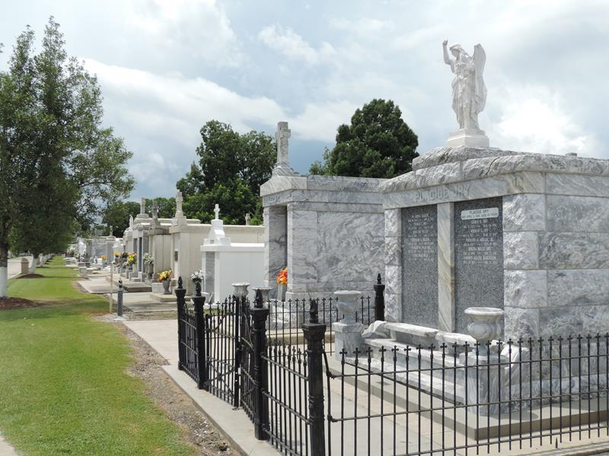

Clifford “Cliff” Anthony Hebert passed away peacefully at St. Joseph Hospice on Friday, June 28, 2019, age 72. A native of Lions, LA and a resident of LaPlace, LA.
Beloved husband of Jimmy Lou Guidry Milioto Hebert. Father of Stacy Richoux (the late Greg) and Blake Hebert (Brandy). Step-father of Chad Milioto (Jenni), Heather Gilberti (Joe), and Ryan Milioto (Raquel). Devoted grandfather of Evan and Elise Richoux, Brennan and Julia Gilberti, and Lily and Bennett Milioto. Step-grandfather of Blaize, Justice, and Breann Marino; Megan Perilloux (Josh); and Macy Miley and Robert Miley, Jr. Son of the late Elmer and Kathryn Hebert. Brother of Gail Dye (Roy), Cindy Brown (Greg), and Kathy Jo Mayfield (the late William). Brother-in-law of Pat Guidry (Barbara), Nelson Guidry (the late Elle), Jules Guidry (Rhonda), and Cindy Hogan. Also survived by many loving nieces and nephews.
He retired from DuPont after 36 years of service. A devoted Catholic of St. Joan of Arc Catholic Church and Grand Knight of The Monsignor Bergeron Council 5935. He was a proud member of the LGHS Class of 1965, an avid LSU fan and a member of the Senior Tangi Bowling League. He served on the Board of Ingleside HOA and Old Hwy 51 Association. He was also a US Army Veteran.
The family would like to express their sincere gratitude to Ochsner Main Campus 8th floor nurses and to the St. Joseph Hospice staff for the loving care given to Cliff.
Relatives and friends are invited to attend services. Visitation will be held at St. Joan of Arc Catholic Church, 529 W. 5th St., LaPlace, LA on Wednesday, July 3, 2019 from 9:30 am until a 12:30 pm Mass of Christian Burial. Burial will follow at St. Peter Cemetery in Reserve, LA.
In lieu of flowers donations preferred to The Monsignor Bergeron Council 5935, 346 Fir St., LaPlace, LA 70068.

Rose Lynn Funeral Services, Lutcher, Louisiana

