Joyce (Caronna) Hebert

August 25, 1948 – June 30, 2013

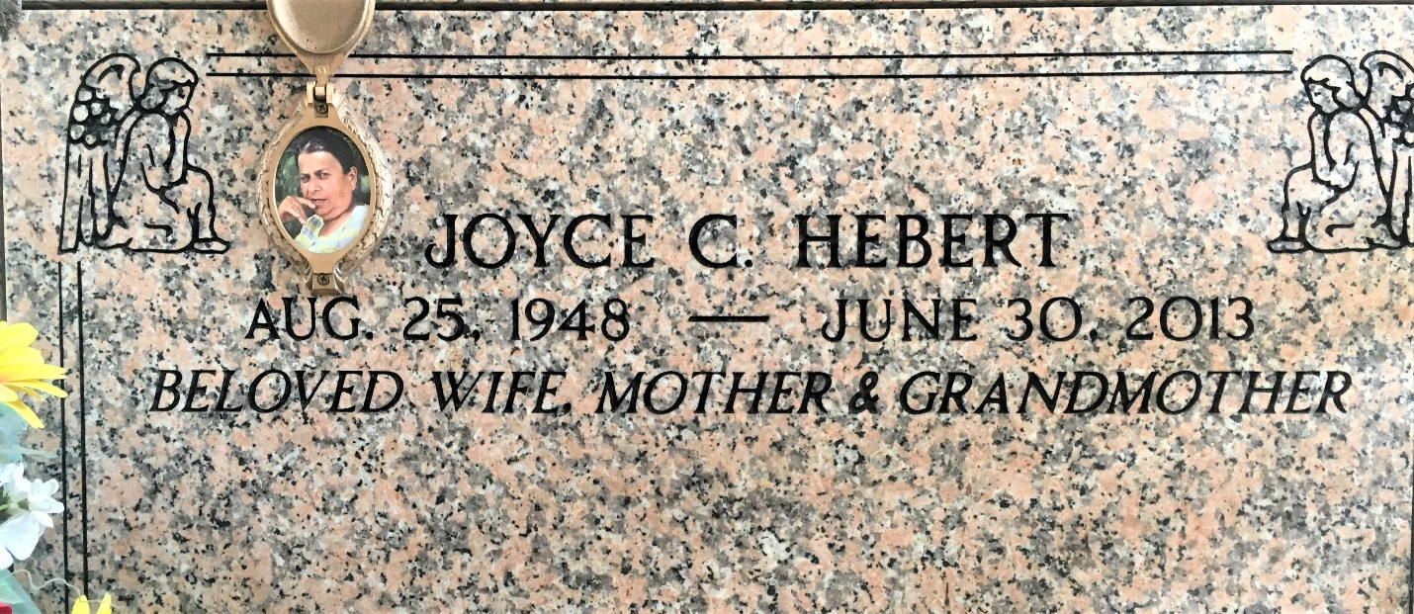

Photo by Team T-Lo

Joyce Caronna Hebert died on Sunday June 30, 2013.

Beloved wife of Vildress (Sonny) Hebert. Mother Toby, J.C. (Mica), Cory (Jessica)and Terri (Corena) Hebert. Grandmother of Taylor, Donavon, B.J., Devin and Chance. Daughter of the late Charles and Vivian Caronna. Sister of Dennis, Tommy and Roy Caronna, Lois Richard and Nettie Carter. Age 64. A native and resident of LaPlace, LA.

Relatives and friends are invited to attend services. Visitation at Millet-Guidry Funeral Home, 2806 W. Airline Hwy, LaPlace, LA on Friday, July 5, 2013 from 5:00pm to 9:00pm and on Saturday from 8:00am to 10:00am, followed by Mass in the Funeral Home Chapel, at 10:00am. Burial in St. Peter Cemetery, Reserve, LA.

The Times-Picayune, New Orleans, Louisiana

Jul. 1 to Jul. 3, 2013