Lucille (Barbier) Hebert

September 24, 1923 – May 7, 2005

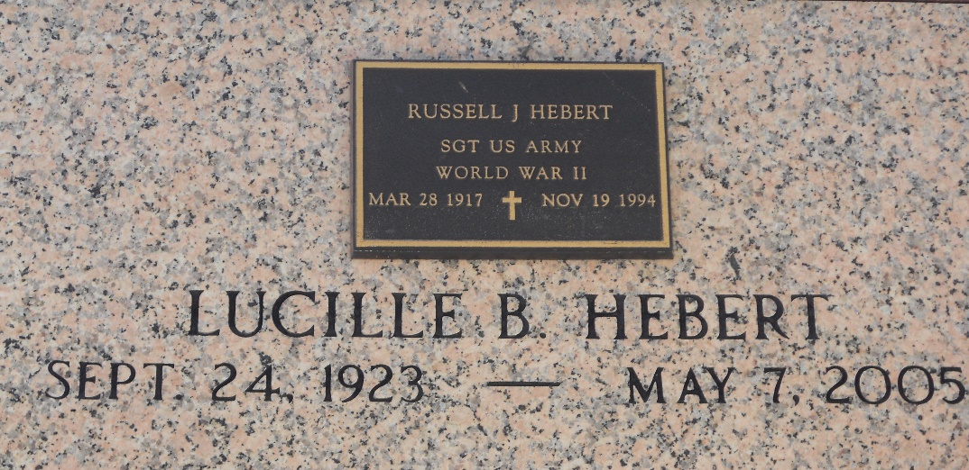

Photo by Team T-Lo

Lucille Barbier Hebert, on Saturday, May 7, 2005 At 4:22 A.M. Age 81 Years. A Native Of Lobdell, La And A Resident Of Metairie For The Past 59 Years.  
 Beloved Wife Of The Late Russell J. Hebert. Mother Of Karin Price. Grand- mother Of Charlene Gale And John Turner. Great-Grandmother Of Barrett, Nicholas And Mariah Gale. Sister Of Frances Williams And The Late Thelma Melancon.  
 Relatives And Friends Of The Family Are Invited To Attend Services. Visitation At Millet-Guidry Funeral Home, 2806 W. Airline Hwy., In Laplace On Tuesday, May 10, 2005 From 9:00 A.M. Until 11:00 A.M. Followed By Religious Services At The Funeral Home Chapel At 11:00 A.M. Burial In St. Peter Cemetery In Reserve.

In Lieu Of Flowers, Donations Preferred, To The River Region Hospice, 507 Upstream St., River Ridge, La 70123.

The Times-Picayune, New Orleans, Louisiana

May 8, 2005