Milton Joseph Hebert

February 27, 1928 – March 16, 1962

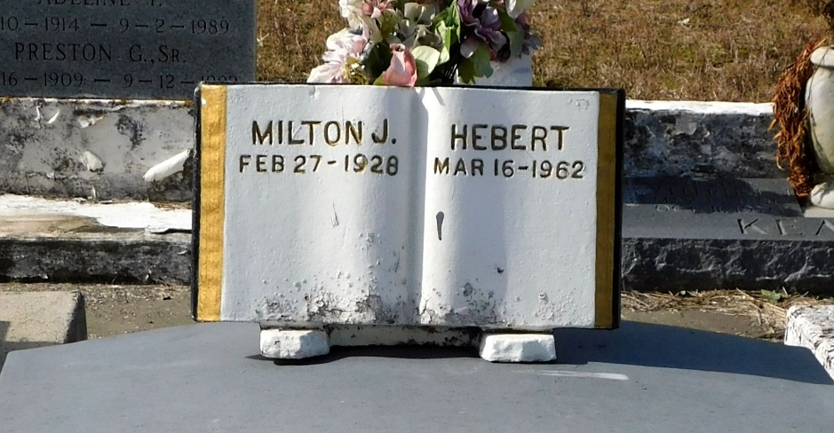

Photo by Mary Agnes Hammett

HEBERT – On Friday, March 16, 1962, at 9:15 o’clock a.m., Milton Joseph Hebert, beloved husband of Lillian Vicknair, father of Laura Mae, Linda, Della, Patsy, Julia, Audrey, Milton Jr., Michael, Rauol and Ralph Hebert; age 34 years, a native of Lafourche parish and a resident of Montz, La.

Relatives and friends of the family are invited to attend the funeral. Services from Millet Funeral Home, Laplace, La., on Sunday, March 18, 19962, at 2:30 o’clock p.m. Interment in St. Peter cemetery, Reserve, La.

The Times-Picayune, New Orleans, Louisiana

Sunday, March 18, 1962, p. 8