Percy Daniel Hebert

July 13, 1907 – February 9, 1974

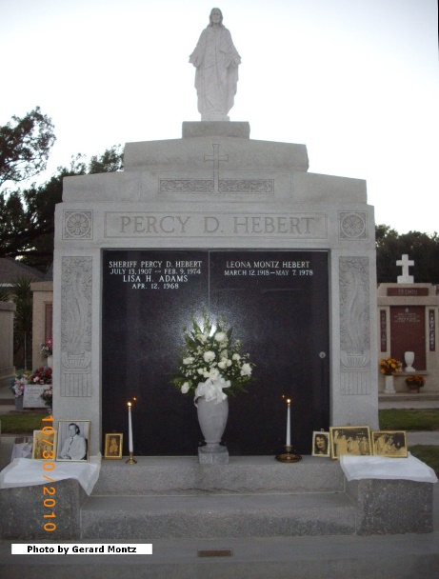 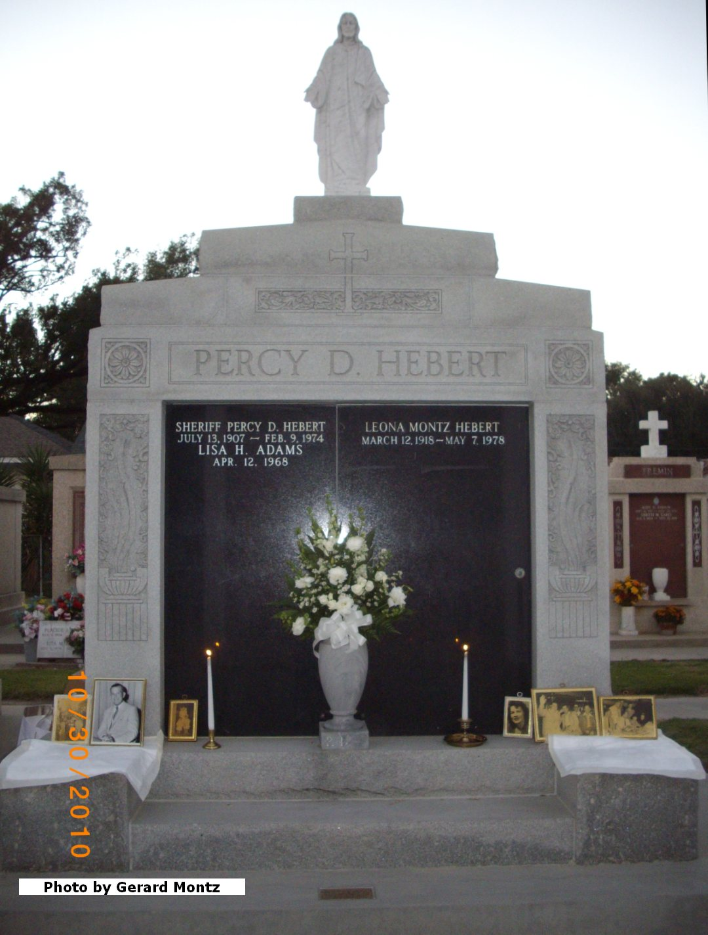

Contributed by Dwayne Montz

Percy D Hebert, Sheriff, St John the Baptist Parish, 1941 – 1974

By Dwayne Montz  
  
 Percy D Hebert was born in Lions, Louisiana, on 13 Jul 1907. He graduated from Leon Godchaux High School, Reserve, Louisiana, in 1926. He worked as a heavy equipment operator for a construction company prior to working at the Godchaux Sugar Refinery. He later worked as an assistant chemist at a sugar refinery in Cuba. He joined the Louisiana State Police force in 1934 and became a motorcycle officer.  
 In 1941 he ran for sheriff of St John the Baptist Parish, Louisiana, and won the election by 263 votes over his politically powerful opponent. During that first campaign, he was known as the "dark horse" candidate and he was the youngest candidate in Louisiana to ever run for sheriff. Sheriff Hebert would become the longest serving sheriff in Louisiana, having served for 32 years and 10 months until his death in 1974. In 1977 the Laplace, Louisiana, St John Parish office building was dedicated in his honor as the Percy D Hebert Building.