Clarence Donald Hebert Sr.

June 22, 1940 – June 5, 2023

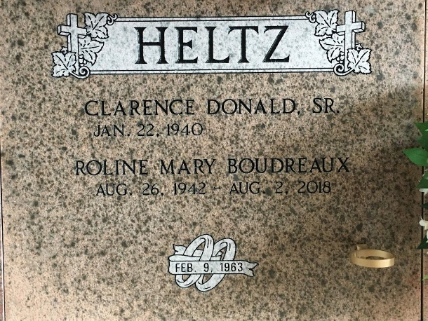

Photo by Team T-Lo

Clarence Donald Heltz, Sr. passed away on Monday, June 5, 2023, at the age of 83.  
 He was born in Garyville, LA was a resident of Reserve, LA and spent his last years near family as a resident of Gonzales, LA. Donald was born and raised in Garyville, LA as the second of nine children. He was a 1958 graduate of Leon Godchaux High School. Donald always displayed a hard work ethic, looking after his siblings, working from a young age at the Star Bakery and then a 39-year career serving the River Parishes as "the Lance Man".  
 He was a member of the Reserve Jaycees and the Reserve Lions Club. He was an active member and coach at the Reserve Bantam Club during his children's youth. He was an avid sports fan of New York Yankees, LSU, the Saints, Southern Miss and Belhaven Baseball. Donald was very social, never meeting a stranger and discussing the social matters of the time. He loved solving the world's problems, earning him the beloved nickname of "the mayor of Reserve". Donald loved his family and enjoyed any opportunity to get together. Special memories include Tuesday gatherings with his siblings.  
 Special thanks go to the many who cared for Donald over the past few years. Donald was treated for almost six years at Fresenius Kidney Care clinics. He lived most recently at Francois Parc in Gonzales and was loved by their entire staff. We cannot express enough appreciation to his brother Mickey and his family for taking him into his family home after Hurricane Ida. All of these made Donald very happy.  
 Beloved husband of the late Roline Mary Boudreaux Heltz. Loving father of Donald Heltz, Jr. (Karen), Kevin Heltz, Sr. (Tammy), Aimee Green (James), Rachel Powell (Gene) and Traci Ezell (Ron). Grandfather of Daniel (Madisen) and David Heltz, Shelby H. Ledet (Zach), Kevin Heltz, Jr., Caroline Green, Garrett Powell (Casey), and Tyler and Alex Ezell. Great grandfather of Jase, Sawyer and Hayley.  
 Son of the late Clara Loupe Heltz and Richard J. Heltz, Sr. Brother of Richard "Jay" Heltz, Jr. (Monica), Michael "Mickey" Heltz (the late Lotus), Gerrie Laiche (Donald), Ronnie Heltz, Cameron Heltz (Beth) and the late Diana Duhe (Manton), Daniel Heltz (Jane) and Nancy Bourgeois (the late Tim). Brother-in-law of Marlene Blank, Olan Boudreaux and the late Noland and Roland Boudreaux. Also survived by many nieces and nephews.  
 Relatives and friends are invited to attend the Visitation at Millet Guidry Funeral Home 2806 W. Airline Hwy, LaPlace, LA on Thursday, June 8, 2023, from 5:00 p.m. until 8:00 p.m. and on Friday, June 9, 2023, at St. Peter Catholic Church, 1550 Hwy 44, Reserve from 9:00 a.m. until 11:00 a.m. followed by a Funeral Mass at 11:00 a.m. Interment in St. Peter Cemetery.  
  
The Advocate, Baton Rouge, Louisiana

Jun. 6 to Jun. 7, 2023