Dora (Cascio) Heltz

May 14, 1909 – November 25, 1961

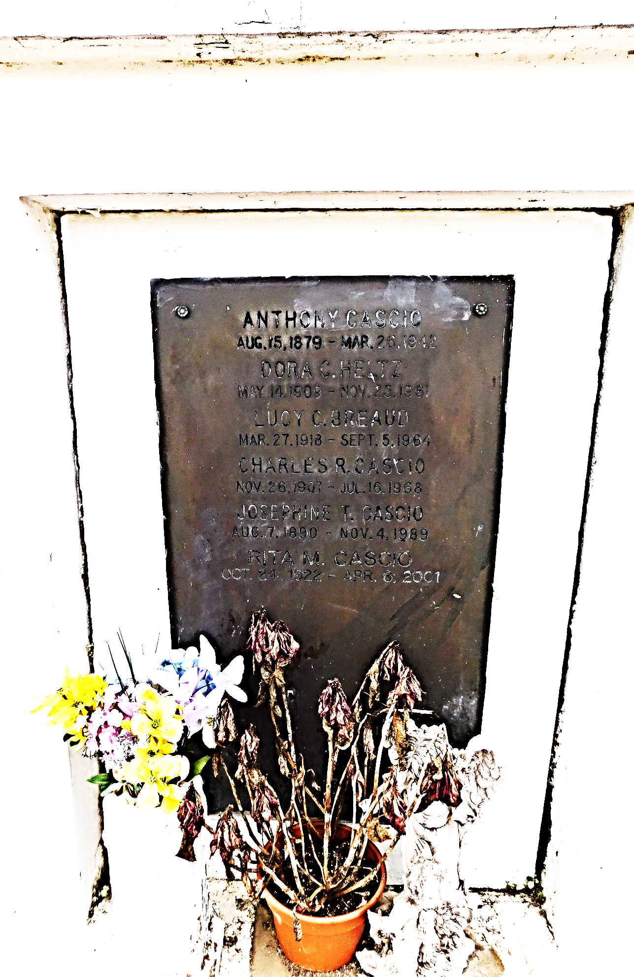

Photo by Mary Agnes Hammet

Louisiana, Statewide Death Index, 1819-1964

Name Dora Cascio Heltz

Age 52

Birth Year abt 1909

Death Date 25 Nov 1961

Death Place Orleans, Louisiana, USA

\*\*

Louisiana, U.S., Compiled Marriage Index, 1718-1925

Name Dora M Cascio

Maiden Name Cascio

Gender Female

Marriage Date 16 Sep 1947

Marriage Place St. John, Louisiana, USA

Spouse Wallace F Heltz

Certificate Number 285??

\*\*

Dora M Cascio from tree Burr-Vesy-Cascio-Tramuta-Sortino-Allen-Castle

Birth 14 May 1909 Orleans, Louisiana, USA

Marriage 16 Sep 1947 Louisiana, USA

Residence 1950 Reserve, St John the Baptist, Louisiana, USA

Death 25 Nov 1961 Orleans, Louisiana, USA

Father Antonino Guiseppe "Anthony Joseph" or "Tony" Cascio (1879-1942)

Mother Giuseppina "Josephine" Filippa Tramuta (1889-1989)

Spouse Wallace Francis Heltz (1901-1967)

1802 People 11 Records 12 Sources