Ernest ‘Mike’ Heltz

March 28, 1920 – January 23, 1991

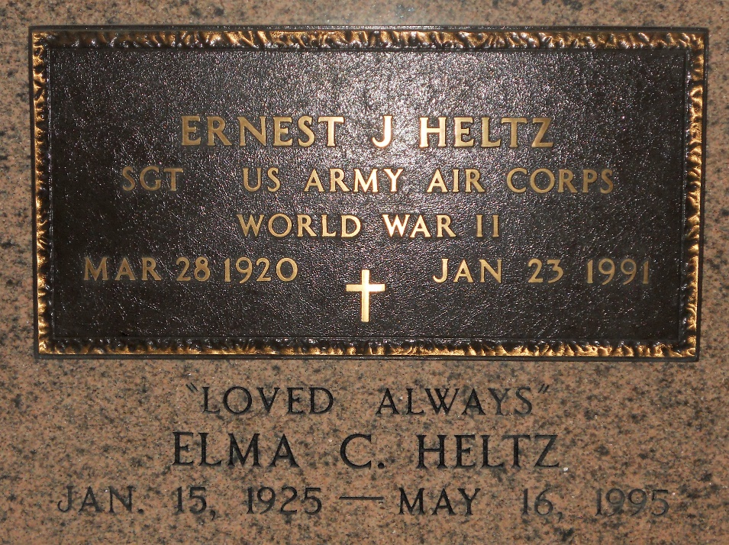

Photo by Team T-Lo

Age 70 years, a native and resident of Garyville, Louisiana.

Husband of Elma Chappell Heltz and father of Chris and Ernest Heltz Jr, Gina Krause, Pamela Montz and Tammy Scontrino. He was the son of the late Mr. and Mrs. Michael Heltz.

Services were Fridan 25 Jan 1991 at St Hubert Church, Garyville, with interment in St Peter Cemetery, Reserve, Louisiana.

The Times-Picayune, New Orleans, Louisiana

24 Jan 1991