Leona Marie (Cambre) Heltz
December 16, 1909 – March 21, 2003

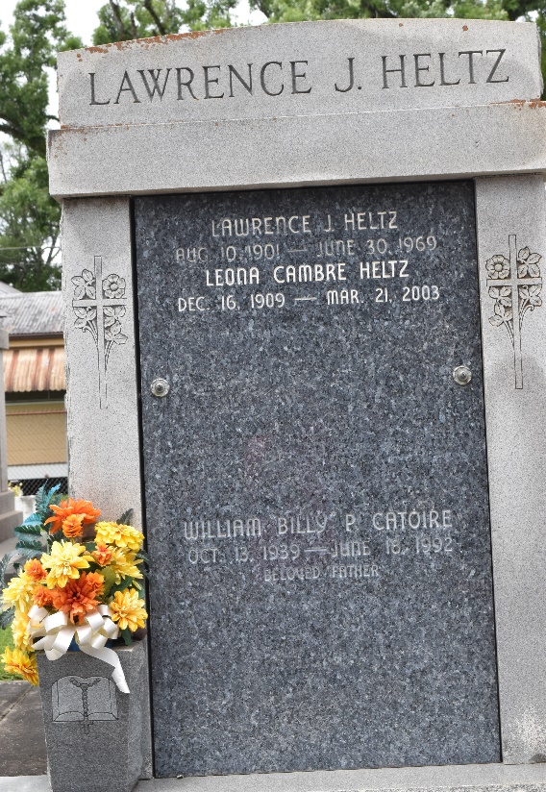
Photo by Team T-Lo

Leona Cambre Heltz On Friday, March 21, 2003 At 12:00 Am.
Beloved Wife Of The Late Lawrence Heltz. Mother Of Dean Heltz Of Athens, Tn. And Darylyn Heltz Leonard Of New Orleans, La. Sister Of Alvin 'Fish' Cambre And The Late J. A. Cambre, Jr. And Iola Cambre Catoire. Daughter Of The Late James Andrew Cambre, Sr. And Louise Elfer Cambre. Special Friend Of Dolores Catoire. A Native And Resident Of Reserve, La.
Relatives And Friends Of The Family Are Invited To Attend The Services At The St. Peter Catholic Church, Reserve, La On Monday, March 24, 2003 From 9:00 Am To 11:00 Am. Followed By Religious Service At The Above Named Church At 11:00 Am. Interment In St. Peter Cemetery In Reserve, La.
Arrangements By Millet Guidry Funeral Home, 2806 W. Airline Hwy., Laplace, La.
Times Picayune, New Orleans, Louisiana
March 23, 2003

