Lydee (Aucoin) Heltz

November 28, 1917 – March 21, 2002

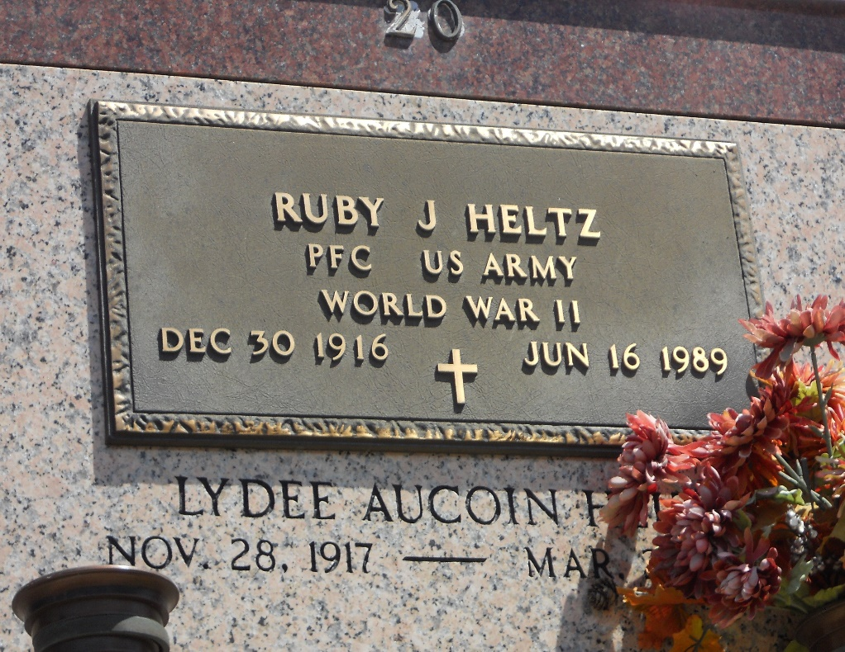

Photo by Team T-Lo

HELTZ LAPLACE – Lydee Aucoin Heltz, 84, a native of Plattenville and resident of Reserve for 68 years, died March 21. She was the wife of the late Ruby Heltz and mother of Anita Millet, Sandra Barre and Dave and the late Raymond Heltz. She was the daughter of the late Achille and Angela Aucoin and sister of Mildred Breaux and the late Agnes Alexander, Manette Cashio, Isabelle Simon and Camille, Medric, Erby, Alex, Claude, Eddie “Chicken” and James Aucoin. She is also survived by three grandchildren and five great-grandchildren. Services are today at 10:30 a.m. In the chapel of Millet-Guidry Funeral Home, LaPlace, with interment at St. Peter Cemetery, Reserve. Visitation starts at 8 a.m.

L’Observateur, Laplace, Louisiana

Monday, March 25, 2002