Richard Joseph Heltz Sr.

March 3, 1913 – November 7, 2001

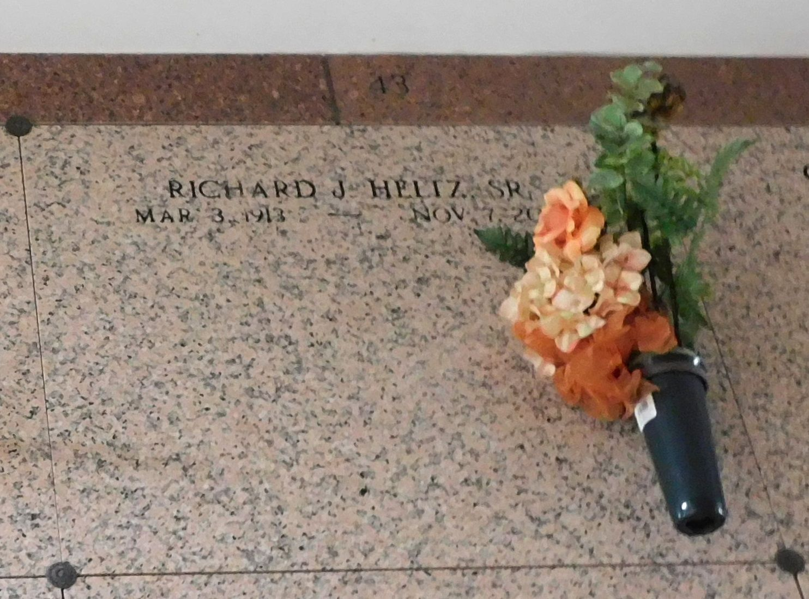

Photo by Mary Agnes Hammett

RESERVE - Richard Joseph Heltz, 88, a native and resident of Garyville, died Nov. 7. He was the husband of the late Clara Loupe Heltz and father of Diana Duhe, Geraldine Laiche, Richard Jr., Clarence Sr., Daniel, Ronnie, Cameron and Michael Heltz and the late Nancy Bourgeois. He was son of the late Michel and Eugine Millet Heltz and brother of the late Wallace, Ruby, Ernest, Douglas, Melvin and Ida Heltz, Allen Zimmer and Rita Braud. He was also survived by 35 grandchildren, 28 great grandchildren. He was preceded in death by one grandchild. Services were Nov. 9 at St. Hubert Catholic Church, Garyville, with interment at St. Peter Cemetery, Reserve.

L'Observateur, LaPlace, Louisiana

November 10, 2001