Roline (Boudreaux) Heltz

August 26, 1942 – August 2, 2018

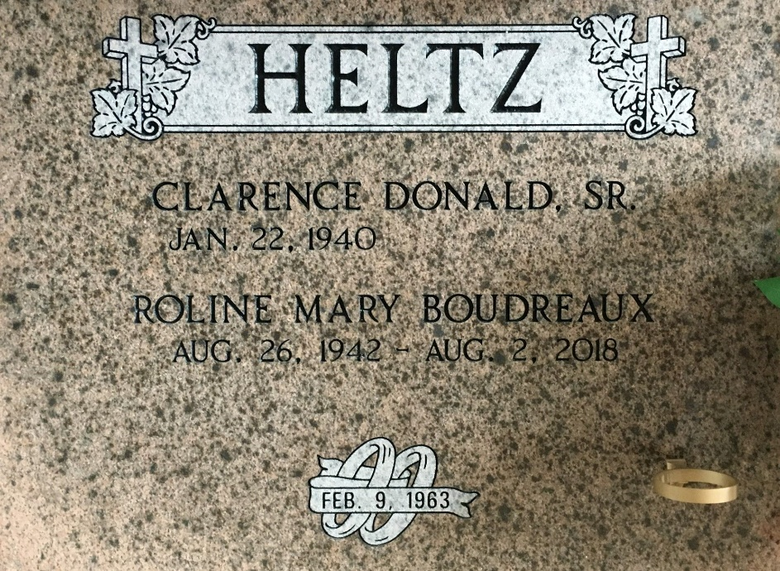

Photo by Team T-Lo

Roline Mary Boudreaux Heltz passed away on Thursday, August 2, 2018, at the age of 75.  
 She was born in Marrero and was a lifelong resident of Reserve, LA, where she was a parishioner of St. Peter Catholic Church. Roline was a graduate of St. Peter Catholic School and Leon Godchaux High School, Class of 1960. She enjoyed sewing, cooking, gardening and jigsaw puzzles. Roline lived for her husband, children and grandchildren.  
 Beloved wife of 55 years to Donald Heltz, Sr. Loving mother of Donald Heltz, Jr. (Karen), Kevin Heltz, Sr. (Tammy), Aimee Green (James), Rachel Powell (Gene) and Traci Ezell (Ron). Grandmother of Daniel and David Heltz, Shelby H. Ledet (Zach), Kevin Heltz, Jr., Caroline Green, Garrett Powell (Casey), and Tyler and Alex Ezell. Great grandmother of Jase and Sawyer. Sister of Marlene B. Blank and Olan Boudreaux (Mary Anne).  
 She was preceded in death by her parents, Nolan and Bernadette Babin Boudreaux and her brothers, Noland "Tiny" Boudreaux and Roland Boudreaux.  
 Relatives and friends are invited to attend the Funeral Mass at St. Peter Catholic Church, 1550 Hwy 44, Reserve on Saturday, August 4, 2018, at 11:00 a.m. Visitation will begin in church at 9:00 a.m. Interment in St. Peter Cemetery. Arrangements by Millet-Guidry Funeral Home.  
  
The Advocate, Baton Rouge, Louisiana

Aug. 3 to Aug. 4, 2018