August Martin Hoffman Jr.

October 17, 1923 – January 22, 2011

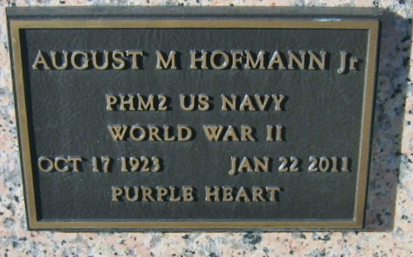

Photo by Bobby

August "Buddy" Martin Hofmann Jr. of Reserve, Louisiana, beloved husband, father, grandfather and great-grandfather passed away peacefully on Saturday, January 22, 2011.

As a 2nd class Corpsman in the United States Navy, he served in World War II and participated in the 3rd Marine Division. He was awarded a Purple Heart after being wounded in WWII, a Presidential Unit Citation insignia for the 3rd combat team in the Marines, and a Navy Unit Commendation award for heroism.

A few years later he was a graduate of Loyola University of New Orleans and earned a degree in Business. He worked as an IRS Agent and Accountant and then later retired as the Post Master of Reserve. He was a member of The Knights of Columbus, VFW, DAV, American Legion, Lions Club and a founding member of Riverlands Country Club. As a lifelong sports enthusiast, he enjoyed golfing, baseball and was a devoted fan of the LSU Tigers and New Orleans Saints football teams. Most of all he was a devoted family member.

Beloved husband of 59 years to Eleanore Schexnayder Hofmann. Devoted father of Wayne (Becky), Steven (Donna), Barbara (Jerry) and Ritchie (Wanda). Paw Paw to 12 grandchildren: Robert Jr., Clay, Byron, Elke, Blaire, Randee, Heather, Brett, Hannah, Ritchie, Jayce, Katie and to 8 great-grandchildren: Ryan, David, Landon, Benjamin, Layla, Kayden, Samantha, Isabella and the love for his many nieces and nephews.

He was preceded in death by his father August Martin Hofmann Sr., mother Julia Dupuis Hofmann, sister Mary Louise Hofmann, brother George Hofmann, son Robert Hofmann Sr. and grandson Steven Paul Hofmann Jr.

Thanks to all the staff at South East Louisiana War Veterans Home in Reserve, Louisiana and Serenity Hospice Care for your compassionate care.

Relatives and friends of the family are invited to attend the Funeral Mass at St. Peters Church in Reserve, LA on Thursday, January 27, 2011 at 10:00 am, visitation at the church is from 8:00-9:45am. Visitation will be held at Millet-Guidry Funeral Home on Wednesday, January 26, 2011 from 5:00 - 9:00pm. Burial Services will be followed at St. Peters Cemetery.

The Times-Picayune, New Orleans, Louisiana

Jan. 25, 2011