Steven Hofmann Jr.

September 21, 1981 – February 27, 2009

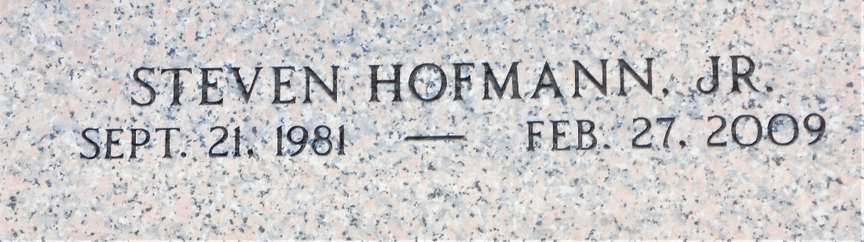

Photo by Team T-Lo

Steven P. Hofmann, Jr. (Stevie), age 27, passed away on Friday, February 27, 2009.  
 He was the beloved husband of Regina Daigle Hofmann and father of Landon and Laila. He Is Also Survived By His Parents Donna D. Hofmann And Steven Hofmann, Sr., Siblings Heather And Jayce Hofmann, And Grand- parents Buddy And Eleanore Hofmann And Leonard Daigle And The Late Merilyn Daigle. Steven Grew Up In Reserve And Resided In Kenner.  
 Family And Friends Are Invited To Attend Services At St. Peter's Church In Reserve At 11:30 A.M. On Thursday, March 5, 2009. Visitation Will Be At Millet-Guidry Funeral Home, 2806 W. Airline, Laplace, La On Wednesday March 4, 2009 From 5-9 Pm And Also On Thursday At 9 Am Until The Funeral.  
  
Times Picayune, New Orleans, Louisiana

March 4, 2009