Fleurange Anna (Montegut) Holden
June 21, 1900 – April 14, 1982

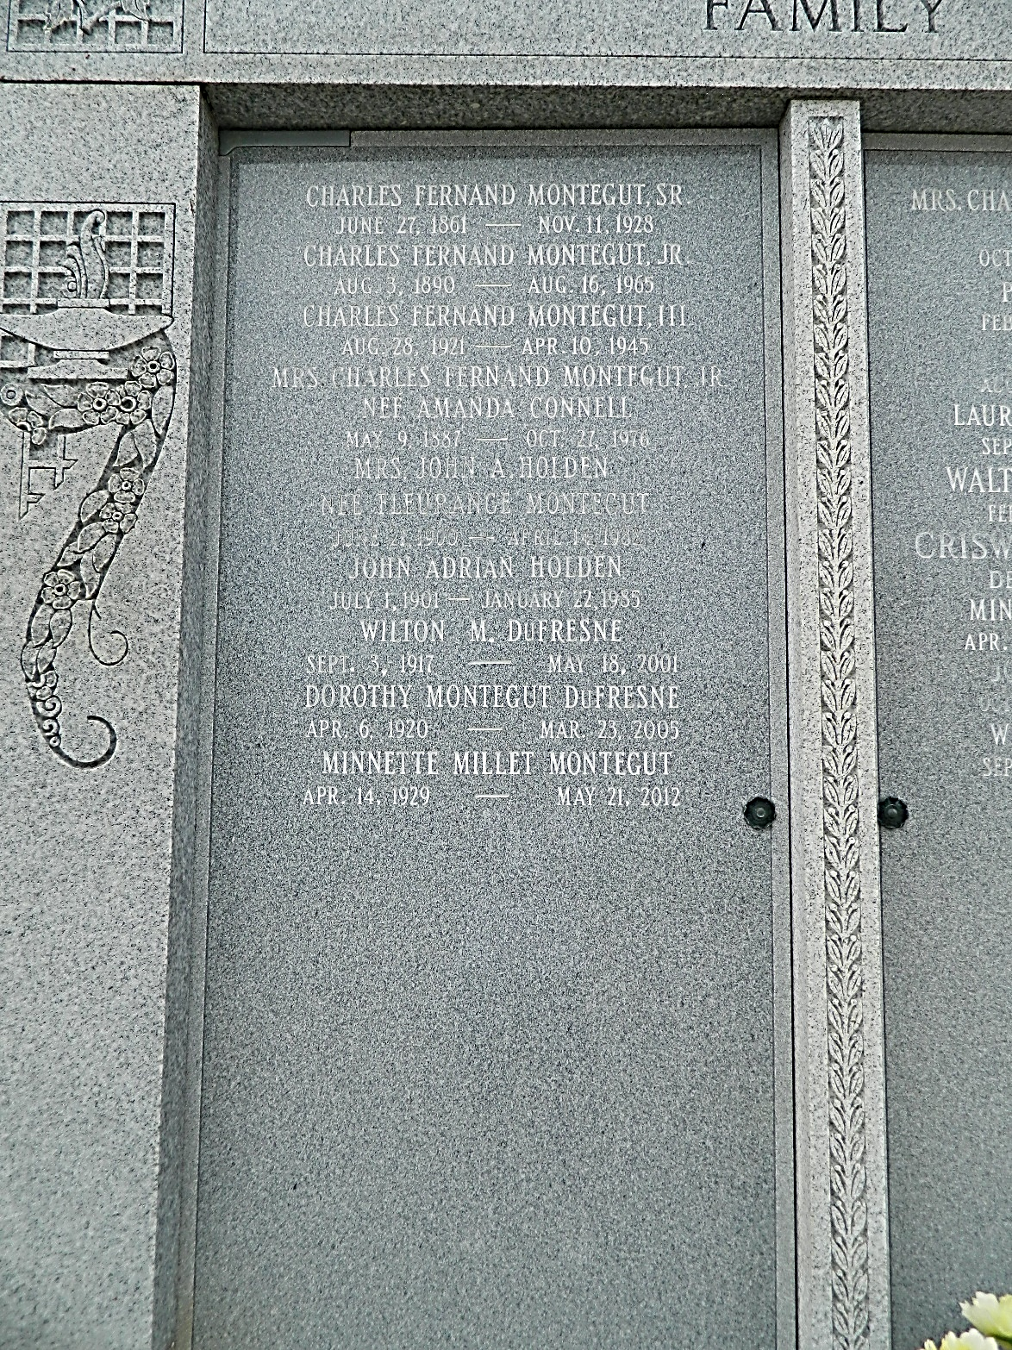

U.S., Social Security Death Index, 1935-2014

Name Fleurange Holden
Social Security Number xxx
Birth Date 21 Jun 1900
Issue year 1956
Issue State Wisconsin
Last Residence 70068, La Place, St John The Baptist, Louisiana, USA
Death Date Apr 1982
**

Fleurange Anna Montegut from tree Holden Family Tree

Birth 21 Jun 1900 Laplace, St John the Baptist, Louisiana, USA
Residence 1953 Milwaukee, Milwaukee, Wisconsin, USA
Death 14 Apr 1982 St John the Baptist, Louisiana, USA
Father Charles Fernand Montegut (1861-1928)
Mother Marie Josephine Elvina Haydel (1863-1956)
Spouse John Adrian Holden (1901-1985)
321 People 13 Records 16 Sources

