William Bourdon Holden
November 2, 1927 – January 16, 2005

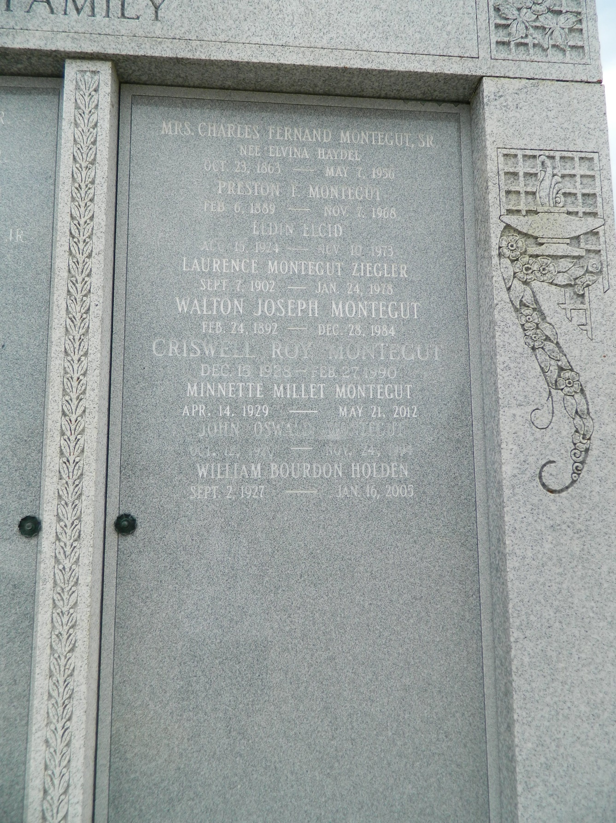

Dr. William B. Holden, 77, a resident of Baltimore, Md., died Jan. 16. He was the father of Lisa Mortimer and Katherine Holden. He was also the brother of Anne Elcid of LaPlace. He is also survived by four grandchildren. Services are today at 11 a.m., in the chapel of Millet-Guidry Funeral Home, LaPlace, with interment at St. Peter Cemetery, Reserve. Visitation starts at 10 a.m.
L'Observateur (La Place, Louisiana)
Monday, January 24, 2005
Contributed by Jane Edson

