Jerry E. Holder

July 28, 1961 – January 29, 2021

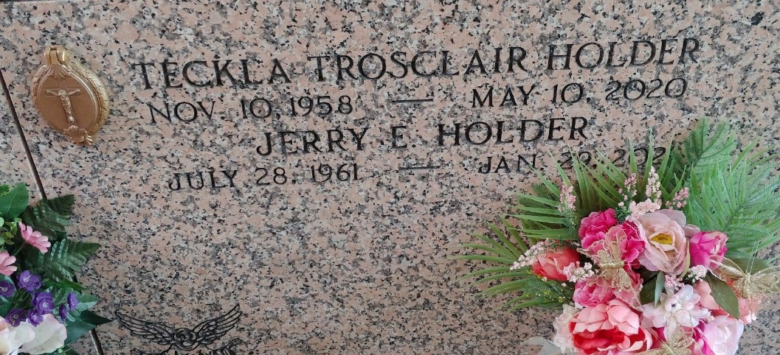

Photo by Team T-Lo

Jerry E. Holder passed away Friday, January 29, 2021. He was 59, born in Hattiesburg, MS and was a resident of Gonzales, LA. He was preceded in death by his wife, Teckla Holder.

Loving father of Philip M. Bourgeois (Loni), Joshua L. Slayton (Nora) and Amy G. Slayton (Alcola). Grandfather of Kallie, Kasey, Lilliana, and Rosalina. Son of the late Bennie Dene Holder and Henry Dow Holder. Brother of Dena Poche (Jimmy). Brother-in-law of Bruce C. Trosclair, Sr. (Patti), DeeAnne Thomas (Patrick), Heidi A. Trosclair, Joetta A. Matt (Wayne), Adam J. Trosclair, Jr., Roy J. Trosclair and the late Staci A. Trosclair. Also survived by many nieces and nephews.

Relatives and friends are invited to attend the Visitation and Funeral at St. Peter Catholic Church,1550 LA-44, Reserve, LA, on Tuesday, February 2, 2021. Visitation will be held from 9:00 a.m. to 11:00 a.m. with the Funeral Service to immediately follow at 11:00 a.m. Interment in St. Peter Cemetery.

Millet-Guidry Funeral Home, LaPlace, Louisiana

February 2, 2021