Teckla (Trosclair) Holder

November 10, 1958 – May 10, 2020

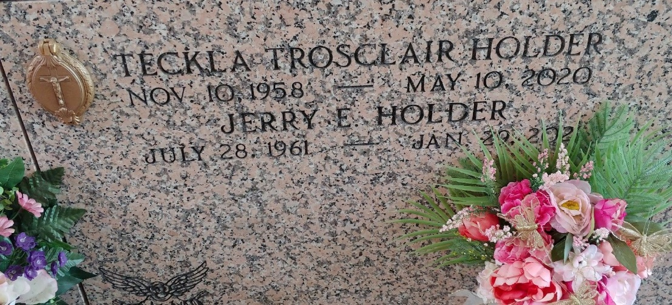

Photo by Team T-Lo

Teckla Trosclair Holder passed away on Sunday, May 10, 2020. She was 61, born in New Orleans, LA and was a resident of Gonzales, LA.

Beloved wife of Jerry Holder. Loving mother of Philip M. Bourgeois (Loni), Joshua L. Slayton (Nora) and Amy G. Slayton. Grandmother of Kallie Bourgeois, Kasey Bourgeois, Lilliana Doiron and Rosalina Slayton. Daughter of the late Diana Catoire Trosclair and Adam Trosclair, Sr. Sister of Bruce C. Trosclair, Sr. (Patti), DeeAnne Thomas (Patrick), Heidi A. Trosclair, Joetta A. Matt (Wayne), Adam J. Trosclair, Jr., Roy J. Trosclair and the late Staci A. Trosclair. Sister-in-law of Dena and Jimmy Poche. Also survived by many nieces and nephews.

As a result of present circumstances, the funeral and committal services are private, but our community of friends are important to us. Please consider sharing your thoughts, favorite memory or condolences at [www.milletguidry.com.](http://www.milletguidry.com/)

The Times-Picayune, New Orleans, Louisiana

May 13 to May 14, 2020