Geraldine (Wallace) Holland

September 15, 1929 – June 9, 2009

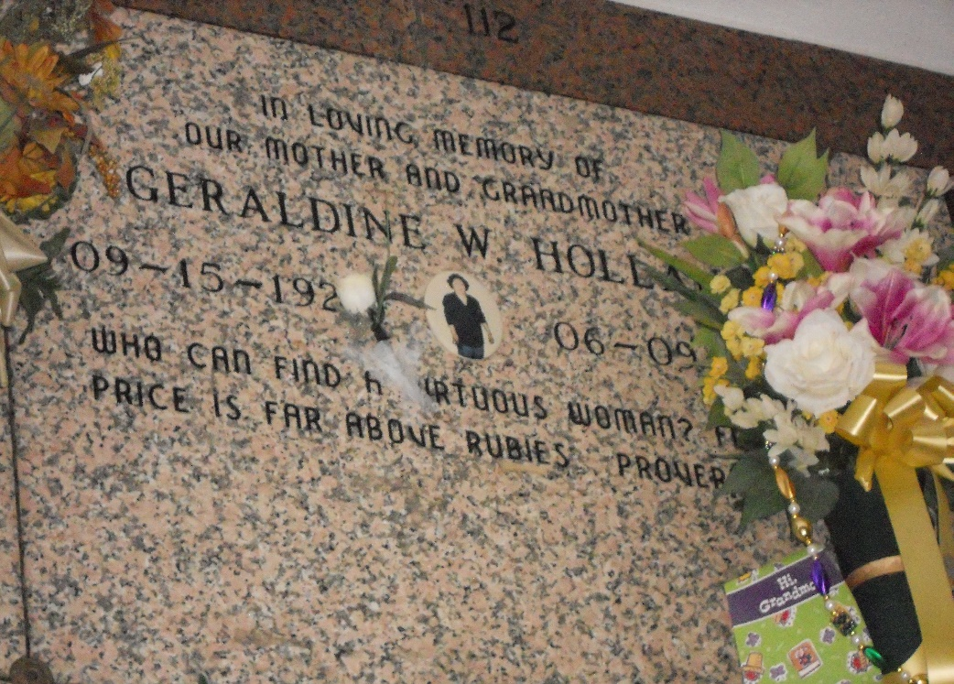

Photo by Team T-Lo

Geraldine Wallace Holland "Gee" On Tuesday, June 9, 2009 At Her Home In Reserve, LA.

Daughter Of The Late Albertha Madere And Willie Wallace, Sr. Husband Of The Late Ernest Holland. Mother Of Druhetta Borne, Ernest Benedict Holland, Erica Nicholas And Andreia Cook. Step Mother Of Ernest Holland, Jr., Sheri, Sonjac And Deshone George, Suzette Moss, And The Late Maise Wright. Sister Of Daphne Mcclean, Shirley Cambre, Gwendolyn, Evelyn, Ferdinand (Diane) And Willie (Lorraine) Wallace Jr. And The Late John Wallace. Also Survived By 22 Grandchildren, 14 Great Grandchildren.  
 Age 79 Years. A Native And Resident Of Reserve, LA.

The Times-Picayune, New Orleans, Louisiana

June 12, 2009