Cecil Fabian Hooper
March 20, 1890 – July 10, 1966

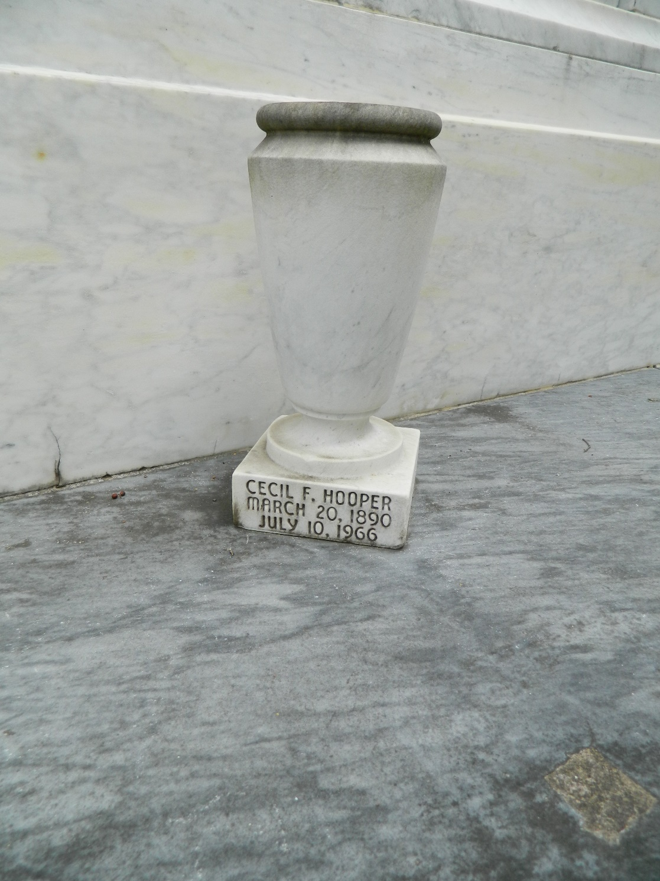

Husband of Caroline St Martin and father of Mrs. Harry Leverette of Lake Charles, Louisiana, Marion Hooper of Metairie, Louisiana, Mrs. Warren Schexnayder of Houma, Louisiana, and Mrs. Peter Hebert of Algiers, Louisiana.

He was a native of Baton Rouge and a former resident of Laplace, Louisiana and of Algiers for the past 10 months.

Services were Monday 11 Jul 1966 at St Joan of Arc Church, Laplace, with interment in St Peter Cemetery, Reserve, Louisiana.

The Times-Picayune, New Orleans, Louisiana
11 Jul 1966

