Blanche Ida (Perilloux) Hotard

January 3, 1898 – August 22, 1975

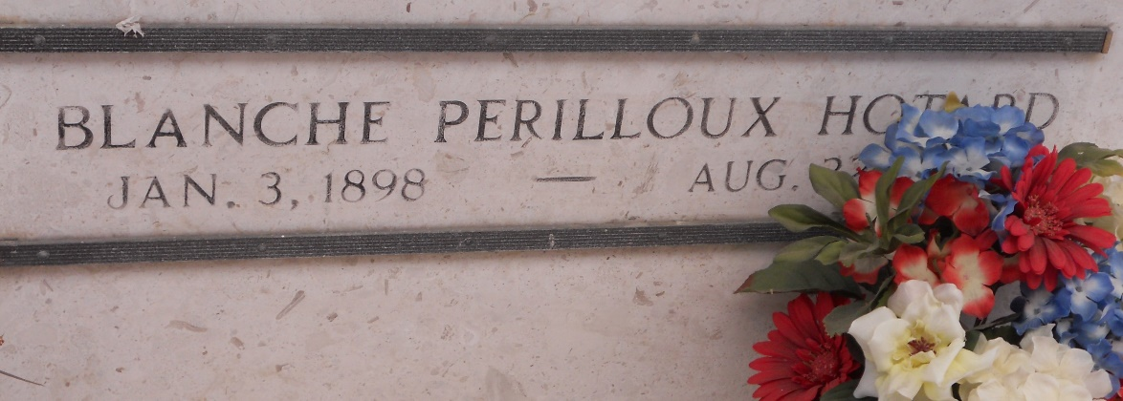

Photo by Team T-Lo

Blanche Perilloux Hotard, a native and resident of Reserve, Louisiana, died Friday, 22 Aug 1975 at 5:45 p.m. at age 77 years.

She was the wife of Emile Hotard Sr. and the mother of Mrs. E. J. (Jewell) Aucoin and Emile Hotard Jr., of Reserve. Also survived by six grandchildren and four great-grandchildren. She was the sister of Bertha and Henry Perilloux and the late Lawrence Perilloux and Maria Ory, and the daughter of the late Mr. and Mrs. A. T. Perilloux.

Services were Monday 25 Aug 1975 at St Peter Church, Reserve, with interment in St Peter Cemetery, Reserve.

Times-Picayune, The (New Orleans, Louisiana)

August 25, 1975