Blanche (Rodrigue) Hotard
April 20, 1915 – May 22, 2006

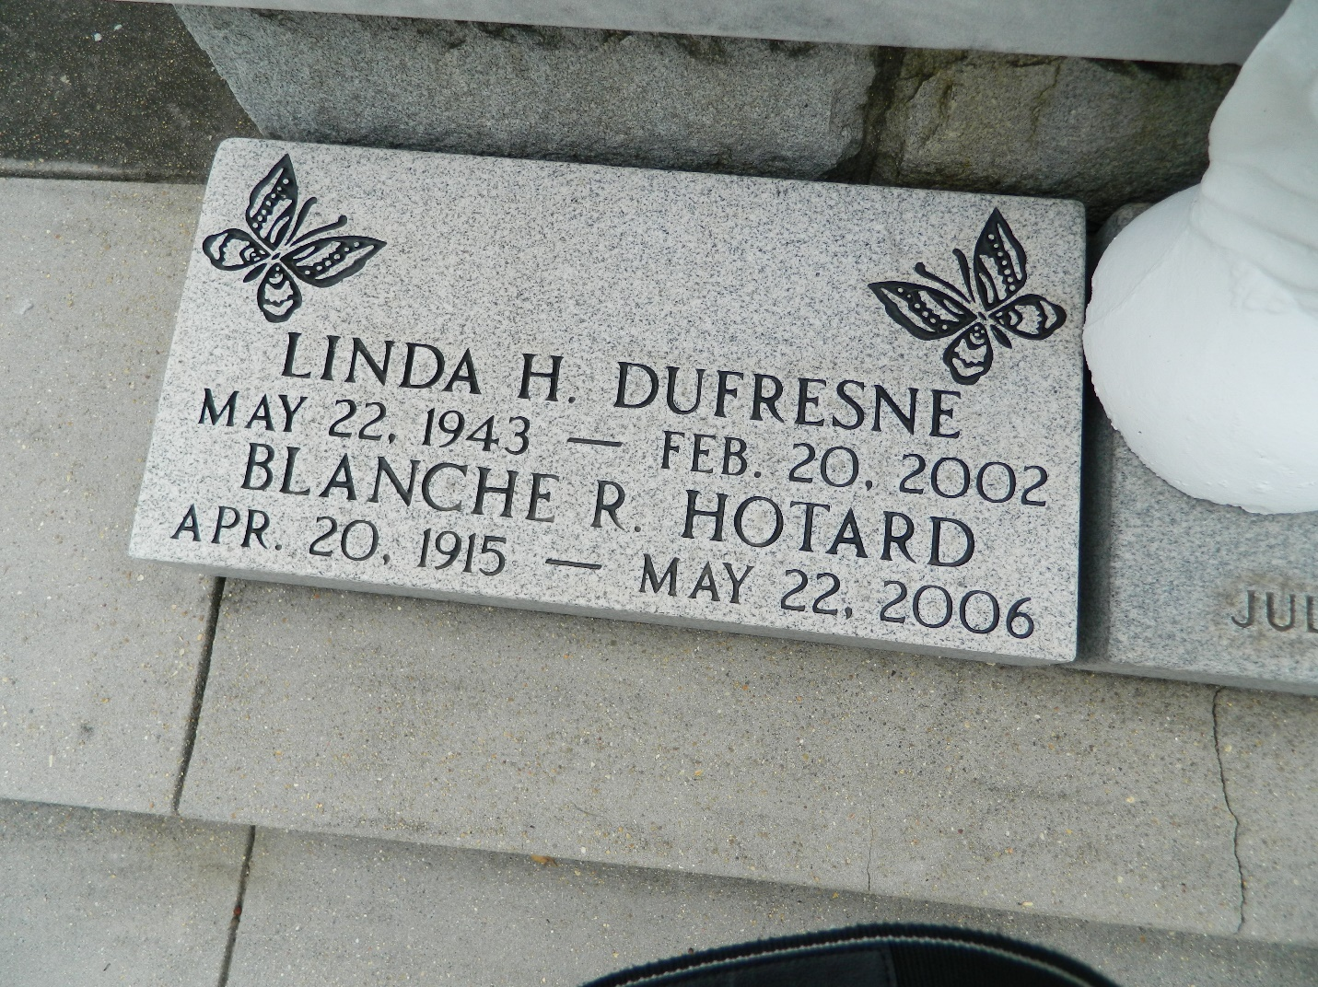

Blanche Rodrigue Hotard on Monday, May 22, 2006 at 5:30 AM.
Beloved wife of the late Simon (Chico) Hotard. Mother of the late Linda Hotard Dufresne. Grandmother of David (Red) Ayme of Bradenton, Florida. Mother-in-law of Barry Dufresne of Dutchtown, LA. Age 91. A native and resident of Reserve, LA.
Relatives and friends of the family are invited to attend services. Visitation at St. Peter Catholic Church, Reserve, LA. on Thursday, May 25, 2006 from 9:00 AM until 11:00 AM followed by religious services at the church at 11:00 AM. Burial in church cemetery. Arrangements by: MILLET-GUIDRY FUNERAL HOME, LAPLACE, LA.
Times-Picayune, The (New Orleans, Louisiana)
Wednesday, May 24, 2006
Contributed by Jane Edson

