Dorothy (Vicknair) Hotard
January 21, 1926 – April 24, 2019

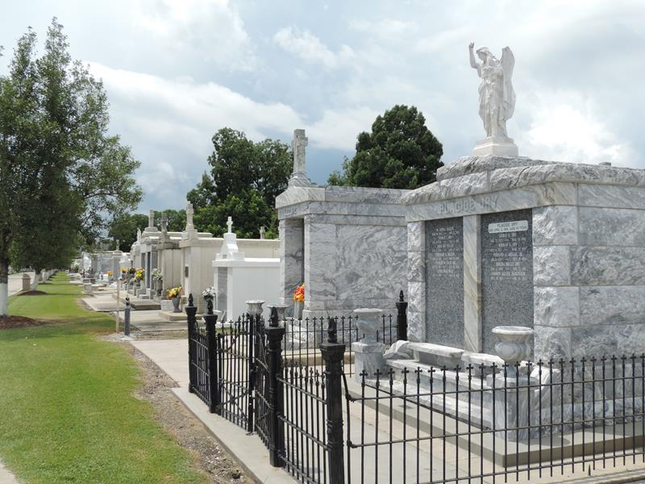

Dorothy Vicknair Hotard, 93, passed away on Wednesday April 24th, 2019. She was a native of Reserve, LA and resident of Convent, LA until moving to Ponchatoula, LA in 2000.
Dorothy “Dot” was best known for her generous spirit and strong Catholic faith. She was a devoted wife, mother and grandmother and most enjoyed spending time with her family.
She is survived by her children, Sidney Hotard, Jr. (Missy), Nadine Higgins (Daryl), Rhenda Hodnett (Paul), Lawton Hotard (Anita), and Callen Hotard (Coleen);brother, Curtis Vicknair (Jeanne); grandchildren, Jackie Havnen( Jon), Julie Chalmers(Ryan), Lindsay Lagasse(Stephen), Erin Tabarrok (Mark), Jarrad Poirrier (Amber), Jayme Millet (Chad), Bryan Hodnett (fiancée Emily Lassus), Brittany Welt (Mike), Courtney Alexander (Stephen), Jason Hotard (Ashley), Cody Hotard and Carly Hotard. Dorothy is also survived by 24 great-grandchildren and her close friend, Carol Smith.
Dorothy was preceded in death by her husband of 63 years, Sidney J. Hotard Sr.; parents, Edgar and Odile Klibert Vicknair; brother, Edgar Vicknair, Jr.; sister, Mary Vicknair Ragsdale and one great- grandchild, Randall “Tripp” Roth III.
Dorothy’s family would like to thank her many caregivers for their care and compassion over the recent years.
Visitation will be on Monday April 29th, 2019 beginning at 10:00am at St. Peter Catholic Church in Reserve, LA. A Mass of Christian Burial will be celebrated at 12 Noon at the church with burial following in the Church Cemetery.

Rose Lynn Funeral Service, Lutcher, Louisiana

