Eliza Alice (Levet) Hotard

September 5, 1865 – July 1, 1942

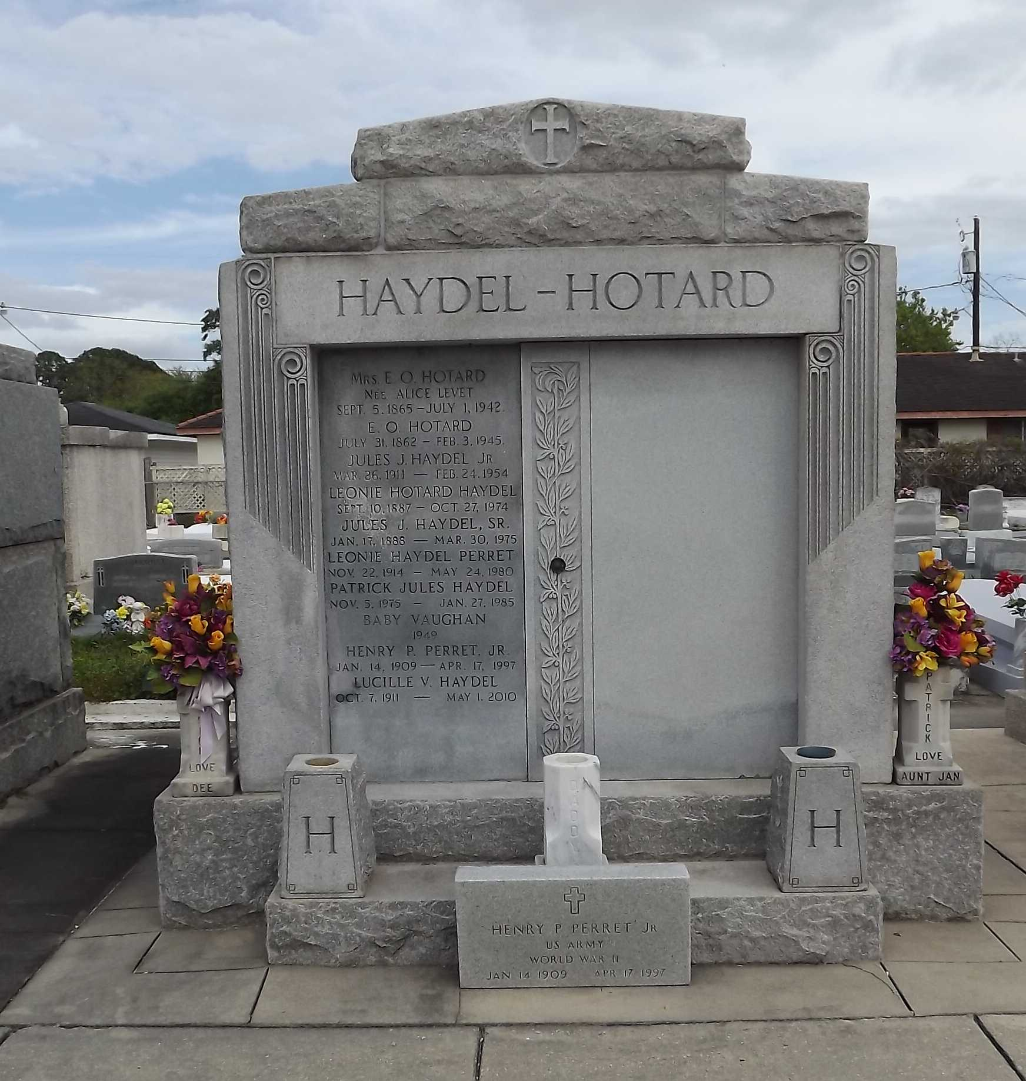 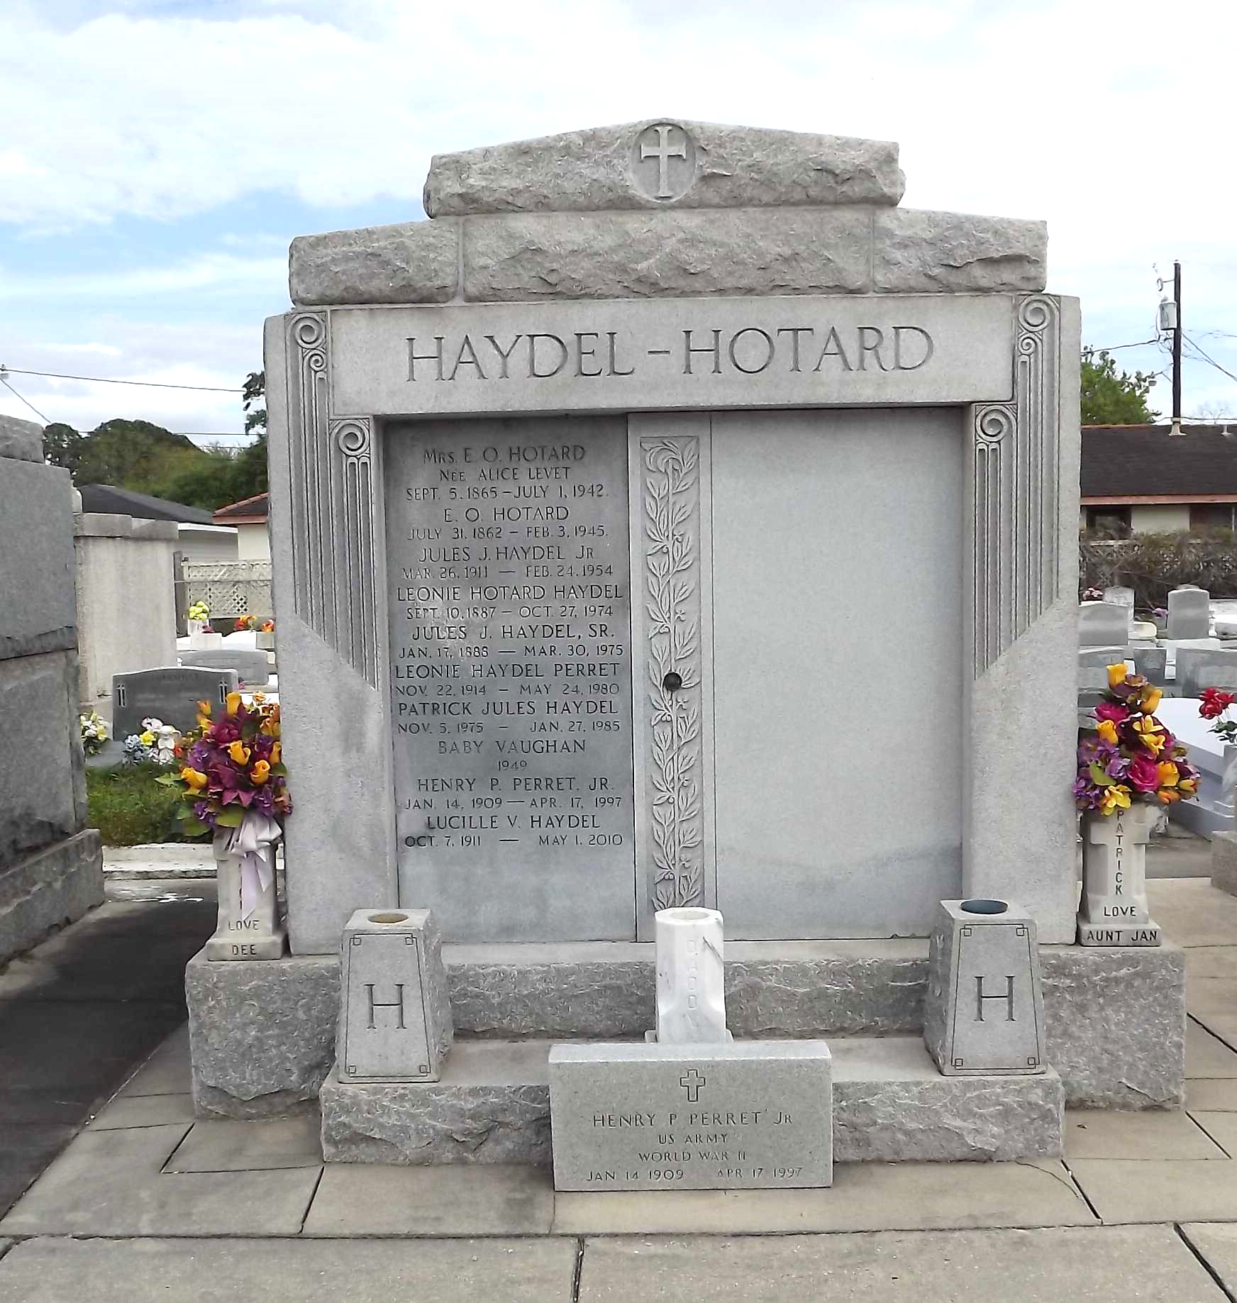

Photos by Mary Agness Hammett

HOTARD - At her residence in Reserve, La, on Wednesday, July 1, 1942, at 3:30 o'clock a.m., ALICE LEVET, beloved wife of Etienne Ozeme Hotard, mother of Mrs. Jules J. Haydel, Sr, of Lions, La, H.N.X. and Emile D. of Reserve, La, and O.F. Hotard of Thibodaux, La, sister of Mrs. Alcide Bacas and of the late Mrs. Leon Abadie of Wallace, La, also survived by 15 grandchildren and 20 great grandchildren, aged 77 years.

Relatives and friends of the family are invited to attend the funeral, which will take place Thursday, July 2, 1942, at 9:30 o'clock a.m., from the Jules P Millet Funeral Home of Reserve, La. Religious services at St Peter church, Reserve, La. Interment in St Peter cemetery, Reserve, La.

The Times-Picayune, New Orleans, Louisiana

2 Jul 1942, p. 2