Emile Dominic Hotard Jr.

April 8, 1923 – April 1, 2016

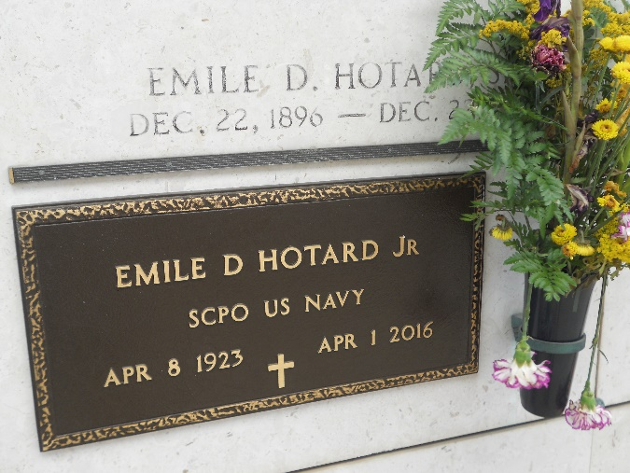

Photos by Team T-Lo

Emile Dominic Hotard, Jr., a retired Navy Senior Chief Petty Officer, passed away on April 1, 2016, at his home.

Born on April 8, 1923, he was 92 years of age. Emile was a lifelong resident of Reserve, Louisiana. In his youth, he served on active duty in the Navy during World War II, the Korean Conflict, the Vietnam Era, and the Berlin-Cuban Crisis. Emile received his bachelor's degree from Louisiana State University and his master's degree from Ole Miss. He impacted many lives as a coach, teacher, principal, and director in the St. John the Baptist Parish Public School System. Emile served for years as president of Emile Hotard Distributors, where he was affectionately known as the 7UP man. Actively involved in his community, he served as a Red Cross instructor, co-Scout-

master of Scout Troop 316, and principal of St. Peter Parochial School. One of his proudest accomplishments was as principal of St. Peter school when he modernized classrooms and increased enrollment.

Emile was a former board member of River Parish Mental Health Clinic, a longtime member of the VFW, a member of the American Legion, Fleet Reserve Association, LA, Retired Teachers Association, a charter member of Reserve Volunteer Fire Department, and a charter member of the National World War II Museum. He was on the Bank of St. John Advisory Board and the Bank of LaPlace Board of Directors. Emile was instrumental in the establishment of the Southeastern Louisiana War Veterans Home and continued to be involved in affairs at the veterans home.

Emile was preceded in death by his mother and father, Blanche Perilloux and Emile Hotard, Sr. He will live on in the hearts of his devoted wife of 46 years, Gerry Landry Hotard; daughters and sons-in-law, Maria Hotard Stelly and Will Stelly; Alison Hotard-Treas and Jaret Treas; a sister and brother-in-law, Jewell and E.J. Aucoin of Reserve and his loving grandchildren, Dominic Stelly, Gabrielle Treas, Anthony Treas, Megan and Ryan Stelly and Katelyn Stelly Gulotta.

Relatives, friends, former students and ball players, veterans, and members of the military are invited to attend a funeral mass at St. Peter Catholic Church in Reserve on Thursday, April 7, 2016, at 12:30 pm. Visitation will be held at Rose Lynn Funeral Home in Lutcher, Louisiana, on Wednesday, April 6, 2016, from 5:30 pm-8:30 pm and on Thursday, April 7, 2016, at St. Peter Catholic Church in Reserve from 9:30 am until funeral services. Active military and veterans are invited to come in uniform to honor Chief Hotard.

Donations in his memory can be made to any of the following organizations: Southeastern Louisiana War Veterans Home in Reserve, Perry's Posse, Food Allergy Research ([www.foodallergy.org/donate](http://www.foodallergy.org/donate)), Trinity Outdoors Disabled Adventures, or childhood cancer organizations such as St. Baldricks, or Cookies for Kids' Cancer.

The New Orleans Advocate, Louisiana

Apr. 4 to Apr. 8, 2016