Emile Dominic Hotard Sr.

December 22, 1896 – December 22, 1982

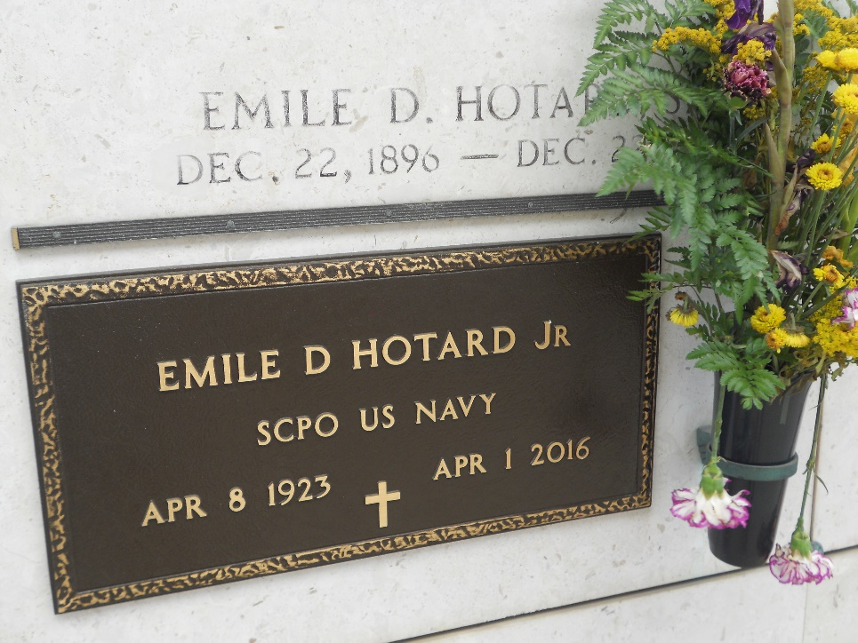

Photos by Team T-Lo

Emile D. Hotard Sr., on Wednesday December 22, 1982 at 1:30 a.m., beloved husband of the late Blanche Perilloux Hotard, father of Mrs. E. J. (Jewell) Aucoin and Emile D. Hotard Jr., grandfather of Debra Jacob, Randy, Kevin and Anne Aucoin, Marie and Allison Hotard, also survived by 7 great grand-

children. Age 86. A native of Edgard and a resident of Reserve for the past 58 years.

Relatives and friends of the family are invited to attend the Funeral Services from Millet Funeral Home, Reserve, on Thursday, December 23, 1982 at 9:30 a.m. Followed by Religious Services at St Peter Catholic Church. Interment in Church Cemetery.

The Times-Picayune, New Orleans, Louisiana

December 23, 1982, p. 21