Etienne Ozeme Hotard

July 3, 1862 – February 3, 1945

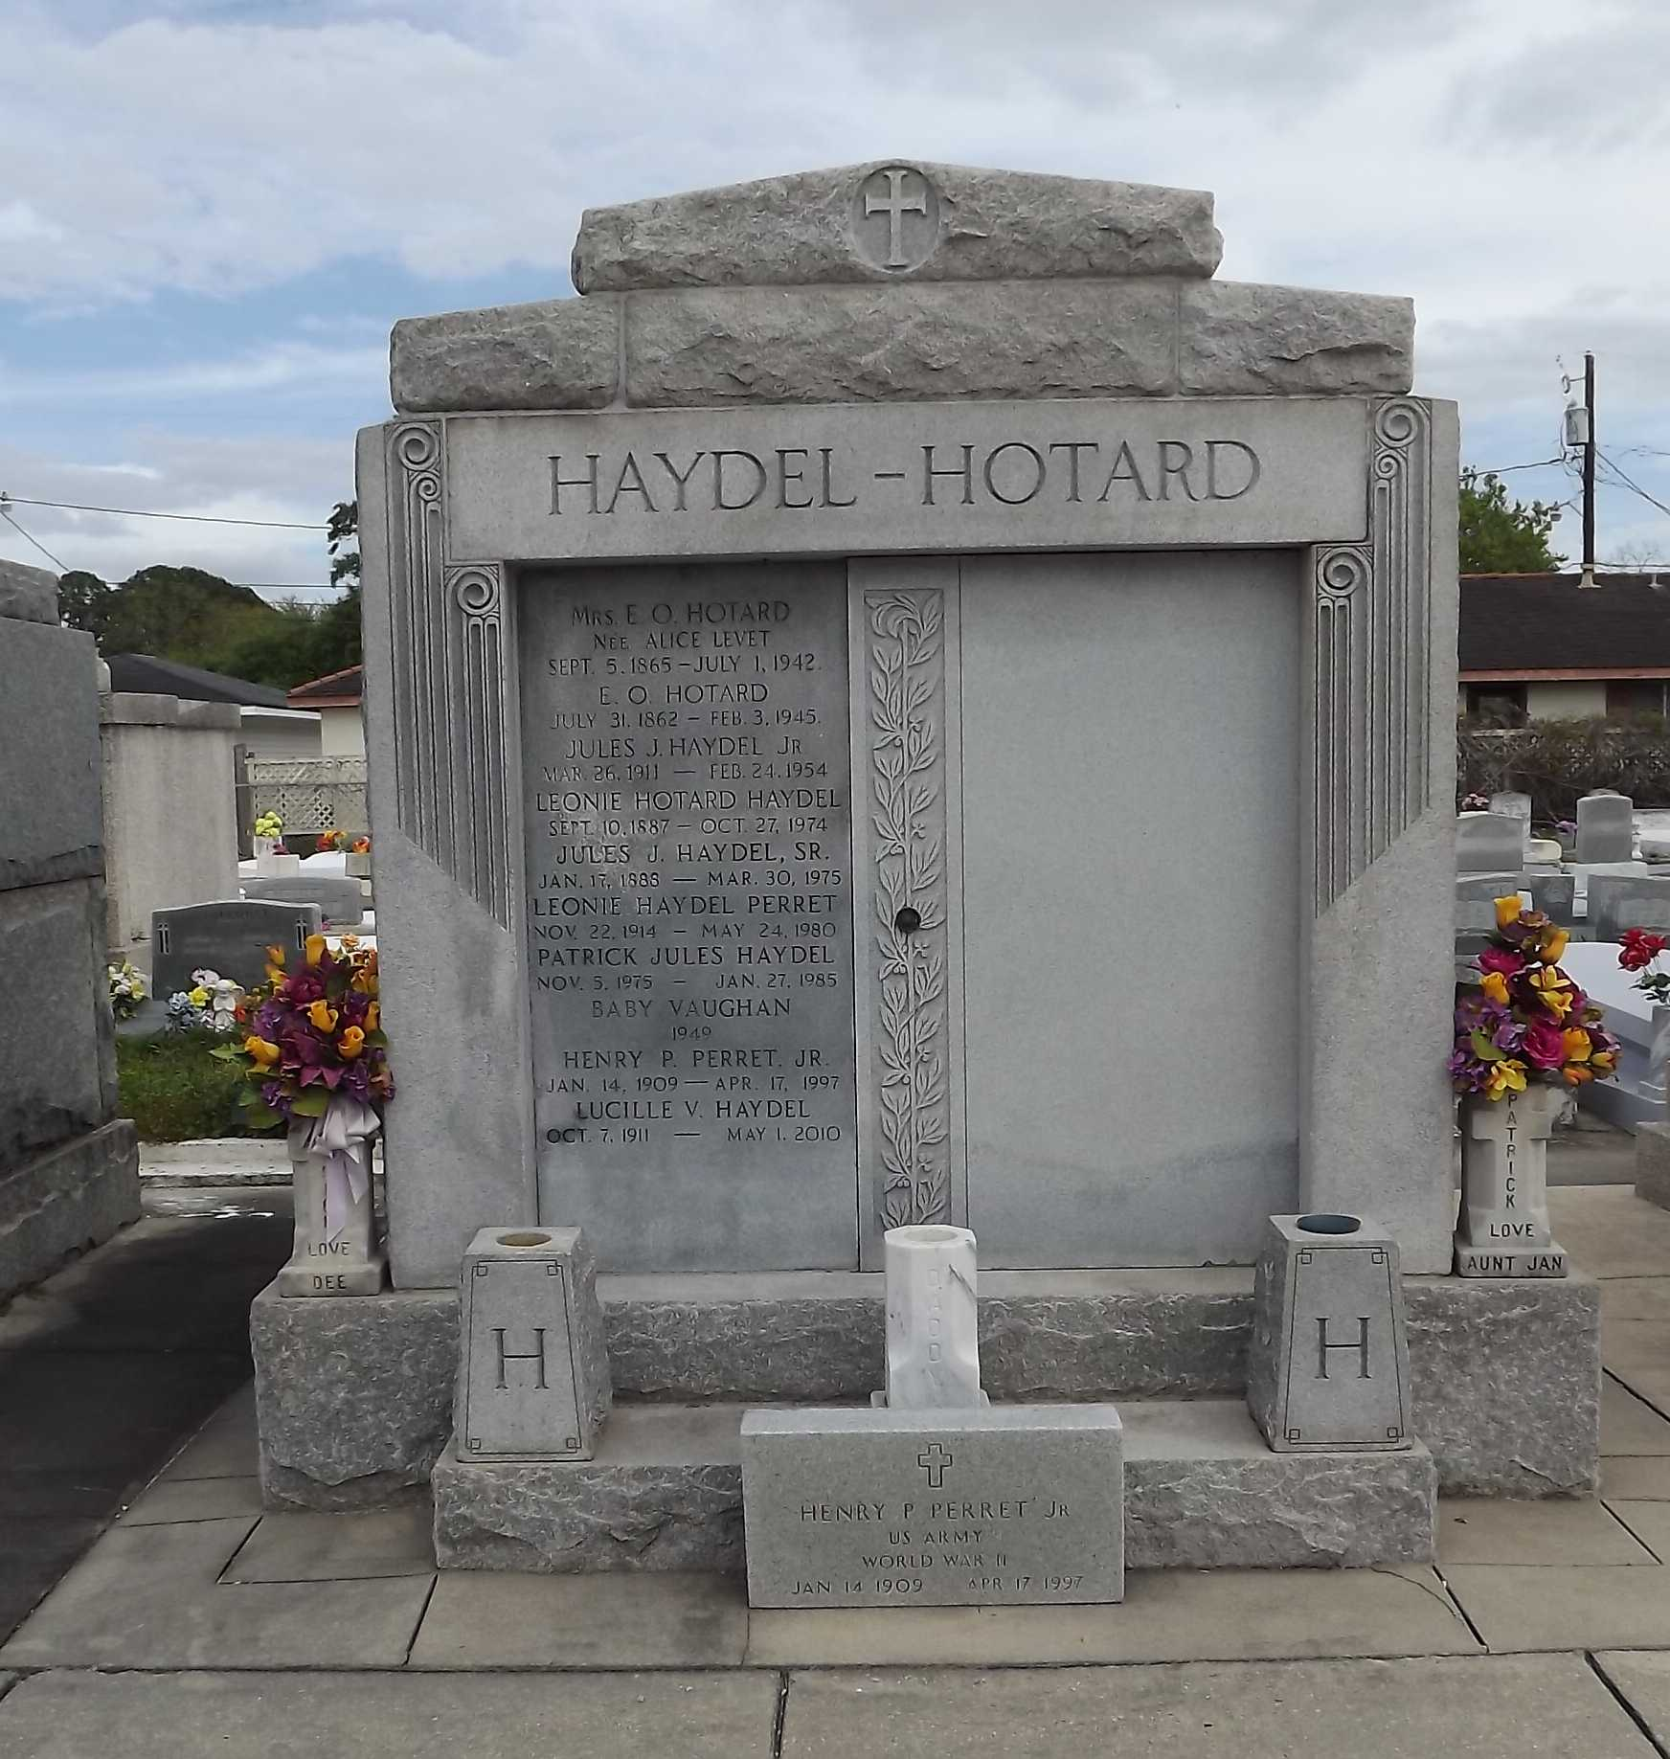 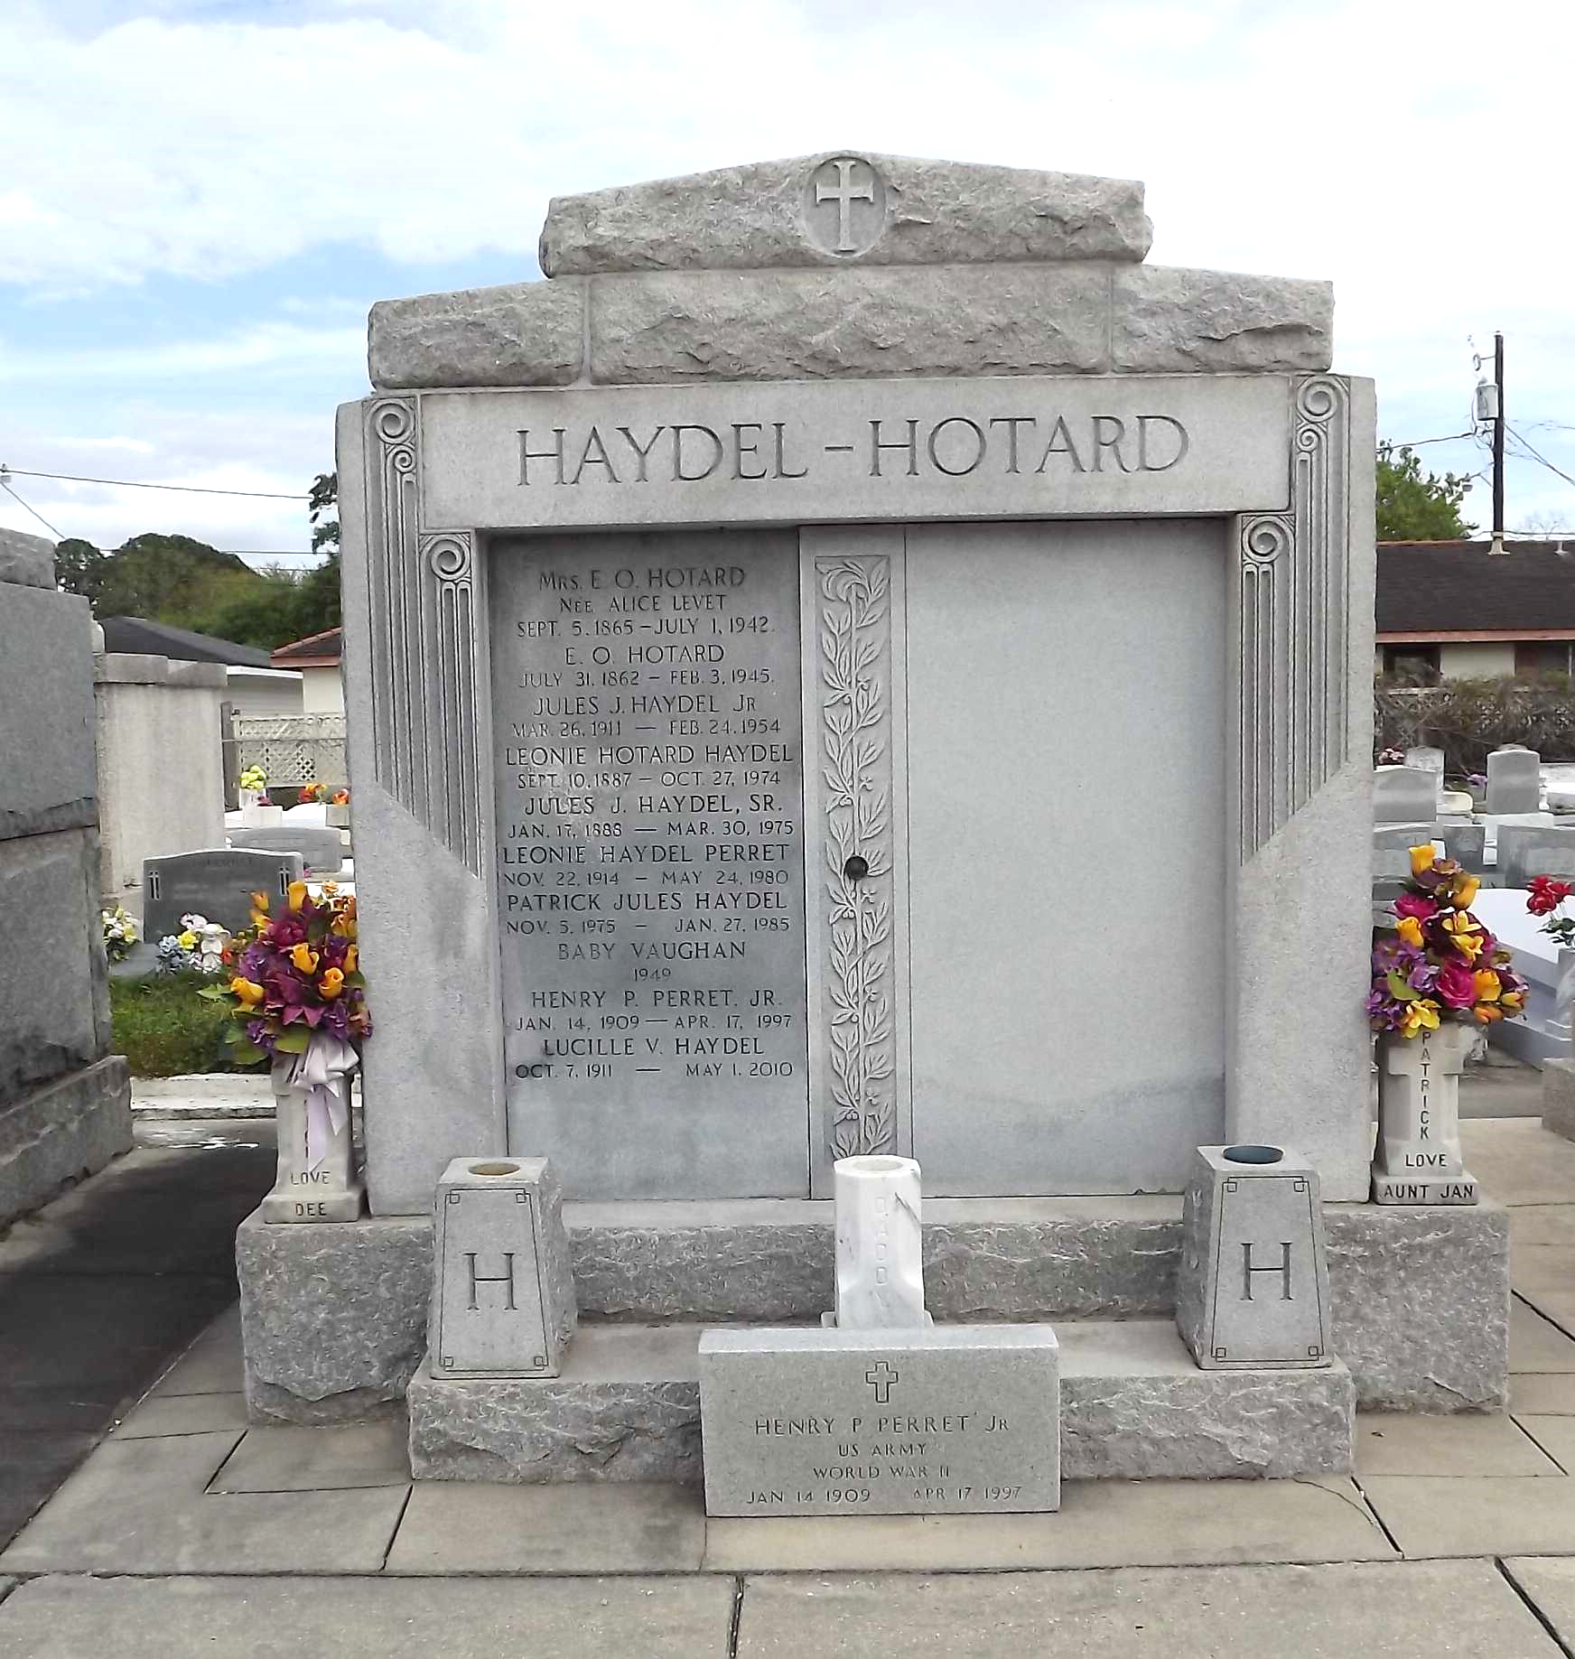

Photos by Mary Agness Hammett

HOTARD - At Hotel Dieu, New Orleans, La, on Saturday, February 3, 1945, at 11:35 o'clock p.m., ETIENNE OZEME HOTARD, husband of the late Alice Levet and father of Mrs. Jules J. Haydel Sr, of Lions, La, Etienne X. and Emile D. Hotard of Reserve, La, and O. S. Hotard of Thibodaux, La, also survived by 15 grandchildren and 24 great grandchildren, aged 82 years, 6 months and 3 days, a native of St John Parish and a resident of Reserve, La, for the past 30 years.

Relatives and friends of the family are invited to attend the funeral which will take place from the Millet funeral home, Reserve, La, on Monday, February 5, 1945, at 9:30 o'clock a.m. Religious services at St Peter's church, Reserve, La. Interment in St Peter's cemetery.

The Times-Picayune, New Orleans, Louisiana

February 5, 1945, p. 2