Etienne Xavier Hotard

June 18, 1885 – January 17, 1966

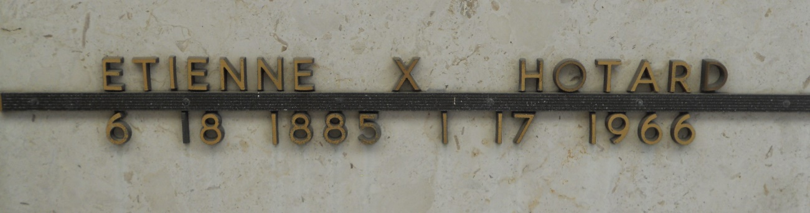

Photos by Team T-Lo

HOTARD – On Monday, January 17, 1966, at 5:30 o’clock a.m., Etienne Xavier Hotard, beloved husband of Regina Simon, father of Henry J., Albert S. Sr., Etienne L. and Sidney Hotard, Amanda H. Audiffred, Mrs. Clifton Williamson and Mrs. Edward A. Sutton, all of Reserve, La., and Miss Rita Hotard of New Orleans, La., son of the late Ozeme Hotard and Alice Levet, brother of Mrs. Jules Haydel Sr., and Emilie Hotard of Reserve, La., and O. S. Hotard of Thibodaux, La., also survived by 27 grandchildren and 20 great-grandchildren; age 80 years; a native of St. John Parish, and a resident of Reserve, La.

Relatives and friends of the family are invited to attend the funeral. Services from Millet Funeral Home, Reserve, La., on Tuesday January 18, 1966, at 11:30 o’clock a.m., religious serves at St. Peter Cemetery, Reserve, La. Parlors will be open Monday at 5 p.m.

Unknown newspaper clipping