Joy (Entremont) Hotard

March 7, 1941 – July 4, 2016

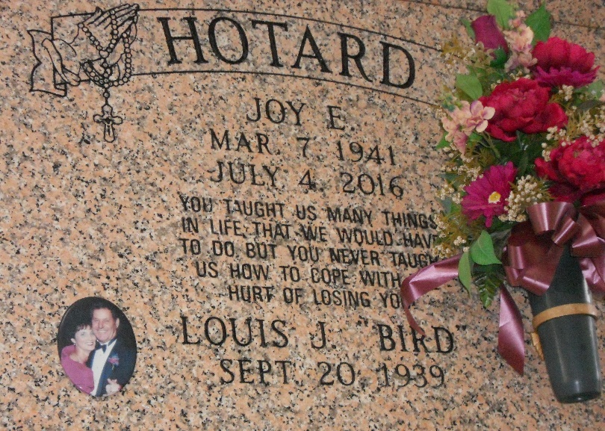

Photo by Team T-Lo

Joy Entremont Hotard, 75, of Reserve, LA was welcomed into heaven on July 4, 2016. She was born on March 7, 1941 to the late Charles Entremont and Frances Entremont who are undoubtedly holding her joyfully in their arms again. She is also preceded in death by her first great-grandchild, Lily Joy Hines. After a long, hard fought battle with vascular dementia, Joy finally found the peace she longed for in the comfort of her Reserve home surrounded by the love of her family. Joy's faith was unwavering and inspiring. She was a devout Catholic and beloved wife and mother.  
 The family is deeply grateful for the outpouring of love, prayers, and support from so many.  
 Viewing will be on Saturday, July 9, 2016 at St. Peter Catholic Church, 1550 Hwy. 44, Reserve, LA from 9:00 a.m. until 12:00 noon followed by a funeral Mass. Interment will be in St. Peter Cemetery in Reserve, LA. Special thanks to Notre Dame Hospice, Caretakers: Eva and Jerry Becnel, Kelly Bailey, Dawn Andro as well as all family members who gave up their time taking care of Joy. In lieu of flowers, Masses preferred.

Rose Lynn Funeral Home, Luther, Louisiana