Rechelle Anne Hotard

April 6, 1971 - February 6, 2019

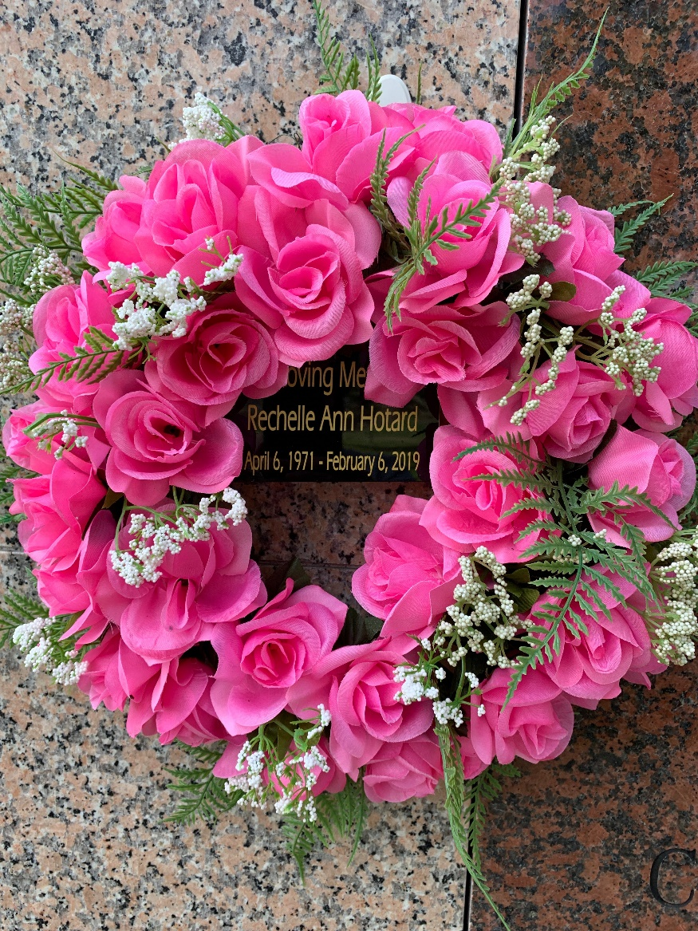

Photo by Team T-Lo

Rechelle Anne Hotard passed away on Wednesday, February 6, 2019, at the age of 47. Beloved mother of Dylan Elmore Boudreaux and the late Kade Edward Boudreaux. She is survived by her parents, Edward Pedro Hotard and Kerry Donley Stacy and two sisters, Kelly Hotard and Jaclyn Hotard. Granddaughter of the late Victoria Cortez Donley and Floyd Donley, Sr., Julia Braud Rezach (Eddie) and Phebus Hotard.

Relatives and friends are invited to attend the Memorial Mass at St. Peter Catholic Church, 1550 Hwy 44, Reserve on Tuesday, February, 12, 2019 at 11:00 a.m. Visitation at the church from 9:00 a.m. until 11:00 a.m. Interment in St. Peter’s Cemetery in Reserve.

Millet-Guidry Funeral Home, LaPlace, Louisiana

February 9, 2019