Rita M. Hotard

January 19, 1919 – December 31, 2012

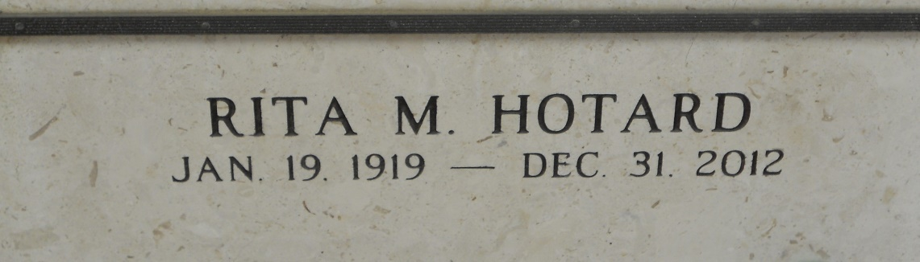

Photo by Team T-Lo

Rita M. (Aunt Rita) Hotard. Passed away on Monday, December 31, 2012.  
  
Beloved daughter of the late Etienne and Regina Simon Hotard. Sister of Marie Hotard Sutton; preceded in death by Henry, Albert, Etienne and Sidney Hotard, Amanda Audiffred and Lucille Williamson. Also survived by 30 nieces and nephews and many great and great-great and great-great-great nieces and nephews.  
  
Devoted employee of Hotel Dieu Hospital for 43 yrs. Age 93. A native of Taft, LA and resident of Reserve, LA.  
  
Relatives and friends also St. Peter Ladies Altar Society and 50 Plus are invited to attend services. Visitation at St. Peter Catholic Church, Reserve, LA on Saturday January 5, 2013 from 9:00 am to 11:00 am, followed by Mass at 11:00 am. Burial in St. Peter Cemetery.  
  
Times Picayune, New Orleans, Louisiana

January 2, 2013